**E-Gunj Bazaar**

**A PROJECT REPORT**

**Submitted by**

**Panchal Mittal S**

WEBSITE DEVELOPMENT

**DECLARATION**

I, Panchal Mittal S. hereby declare that all information and facts presented in this project are first hand in nature and they are actually based on our study.

We have acknowledged the work appropriately where necessary. We have taken care to acknowledge the publications if referred.

Panchal Mittal S.

|  |  |
| --- | --- |
| Place: | Ahmedabad |
| Date: |  |

**INDEX**

* 1.Introduction……………….…………………………………………..………….……….02
* 1.1. Existing System…………………………………..........………..02
* 1.2. Need for the new System…………………….......…………02
* 1.3. Objective of the New System…….....….......……………02
* 1.4. Problem Definition................................................03
* 1.5. Core Components…………………….……...........………….04
* 1.6. Project Profile…………..………….………...........…………..04
* 1.7. Assumptions and Constraint..................................07
* 1.8. Advantages and Limitations of the System.............07
* 2. Requirement Determination & Analysis…………………….......…….……08
* 2.1. Requirement Determination………………..….......…….08
* 2.2. Targeted Users………………………………..……….....………09
* 3. System Design…………….........................…………….……………………….10
* 3.1. Use case Diagram……………………..…………………....…..10
* 3.2. Class Diagram……………………….…………………….....…..14
* 3.4. Activity Diagram……………………………………..…....…….16
* 3.3. Interaction Diagram………..………………….........……….18
* 3.5. Data Dictionary…………………………………….........……..23
* 4. Development…………………………………………………………………...………..27
* 4.1. Coding Standards………………………………..………........27
* 4.2. Screen Shots........................................................28
* 5. Agile Documentation…………..…………………………………….……………….51
* 5.1. Agile Project Charter……………………………….......…....52
* 5.2. Agile Roadmap / Schedule………………............….......55
* 5.3. Agile Project Plan……………………………….....………......57
* 5.4. Agile User Story………………………………….....…………….59
* 5.5. Agile Release Plan……………………………….....………......60
* 5.6. Agile Sprint Backlog…………………………….....……..…….62
* 5.7. Agile Test Plan…………………………………….....……..…….66
* 6. Proposed Enhancement…………………………………………..………………….71
* 7. Conclusion………………………………………………………………..…………………72
* 8. Bibliography…………………………….………………………………...………………73

1) Introduction

* E-Gunj Bazaar is web based system. In E-Gunj Bazaar website we allowing farmers and private persons to set up their own market.
* E-Gunj Bazaar website attempt to solve the grain quality and selling problem. In India there is so much rush for physical selling of grain and vegetable and Fruits and so on in wholesale market. So that E-Gunj Bazaar is constantly operating to provide fast and secure System.
* Now farmers can sell their produce directly to end consumer i.e. Retailers, Bulk buyers, Institution, Group Co-operative Societies, Citizen Associations or any other group buyers on E-Gunj Bazaar .

1.1) Existing System

* In the pre-independence era, farmers were exploited by traders and middlemen, trapping them into selling their produce for low prices than the existing  [market](https://www.toppr.com/guides/business-economics/meaning-and-types-of-markets/market-meaning-and-classification/) rates.
* They were also victims of faulty weighting machines and wrong [accounting](https://www.toppr.com/guides/principles-and-practice-of-accounting/meaning-and-scope-of-accounting/meaning-of-accounting/).
* Unregulated markets
* Moreover, they did not possess storage facilities making then unable to hold back their produce to sell at a better price in future.

1.2) Need For New System

* User and Supplier can register.
* Selling direct to consumers through farmers markets allows farmers to produce and sell in a way that provides more income and consumer contact than would be possible selling through other channels.
* Our focus here is particularly on certified farmers markets and markets organized by and with farmers as owners.
* Supplier can advertise them.
* Cash on Delivery.

1.3) Objective Of The New System

* There is no such website of E-Gunj Bazaar .
* “Increase our sales!
* “Increase our profits!”
* Corruption is reduce .
* Without becoming a circus, markets need to emphasize the experience and meaning of shopping at the local farmers’ market instead of just product. Everybody sells “product”.

1.4) Problem Definition

* E-Gunj Bazaar website attempt to solve the grain quality problem. In India there is so much corruption of selling product like grain and vegetable . So that E-Gunj Bazaar is constantly operating to provide pure and clean grain of best rate and best quality.
* E-Gunj Bazaar website attempt to solve the farmer problem like low rate of product .
* In this pandemic farmer struggle lots of for sale their product like transport service and also they have no storage facility so lots of product like vegetable and fruits are waste so they have to sale that in chipest price .
* In This Website we provide market to farmer where they can easily sale their product with their reasonable price and buyer also purchase from direct farmer so they get best organic product .

1.5) Core Components

1) Supplier:

* Supplier can register.
* Supplier can login.
* Supplier can update profile.
* Supplier can view buyer.

2) User:

* User can register.
* User can login.
* User can update profile.
* User can change password.
* User view Product list.
* User can add product into cart.
* User can place order
* User can make payment.
* User can get print of receipt.

1.6) Project Profile

|  |  |
| --- | --- |
| Team Size | 1 |
| Group Members | 1 |
| Name of group Member | Panchal Mittal S. |
| Project Title | E-Gunj Bazaar |
| Internal Guide | Mr. Parth Goswami |
| Project Duration | 10 January ,2021 To 9 April 2021 |
| Submitted By | Panchal Mittal S. |
| Submitted To | Government MCA Collage(GMCA) |

1.6.1) Introduction of the project:

* E-Gunj Bazaar is web based system. In E-Gunj Bazaar website we Allowing farmers and private persons to set up their own market.
* E-Gunj Bazaar website attempt to solve the grain quality problem. In India there is so much rush for physical sailing of grain and vegetable and Fruits and so on in wholesale market. So that E-Gunj Bazaar is constantly operating to provide fast and secure System .

1.6.2) Objective of the project:

* There is no such website of E-Gunj Bazaar .
* “Increase our sales!
* “Increase our profits!”
* Without becoming a circus, markets need to emphasize the experience and meaning of shopping at the local farmers’ market insteads of just product. Everybody sells “product”.
* Also We stop the chain of growing covid and sell product and provide best product .

1.6.3) Technology & Tools:

* Front End: HTML, CSS, JavaScript, JQuery, PHP.
* Back End: MySqli
* Framework: Laravel
* Tools: Visual Studio Code, Xamp

1.6.4) Hardware Requirement:

* Hard Disk: 64GB or more.
* RAM: 4GB RAM
* Processor: Intel Pentium R

1.6.5) Software Requirement:

* Operating System: Windows 10 or later.
* Browser: Google Chrome,

Mozilla Firefox,

Internet Explorer,

other Browser.

1.7)Assumption and Constraints

* After this website we assume that this website is used for all cities.
* This system does not have forgot password.

1.8) Advantage and Disadvantage of system

1.8.1) Advantages

* Much of the time is saved while shopping for groceries online.
* Customers do not have to wait in a queue.
* They don’t have to wehicle to the load of themselves.
* This is best for old age people and physically handicapped person.
* The overspending can be prevented.
* It is available 24×7 in a year.
* Customer can view their order through order history or looking at the shopping cart.

1.8.2) Disadvantages

* After some hours customer can not cancel order.
* Customer must be knowledge of internet and payment.

2) Requirement Determination & Analysis

2.1)Requirement Determination

* For requirement determination I collect the requirement details and listing of requirements in the website and then create a list of the features.
* The feature list of user in website is described below.

**-: E-Gunj Bazaar Requirements and feature list:-**

* **Login:**
* Create an attractive sliding login page.
* **Registration:**
* Slider Registration Form .
* **View Product:**
* Create Three Categorical Menu.
* In First Category, Grain product that category there are many type of grain likewise rice, wheat.
* In Second Category, Vegetable there are also many type of vegetable like potato , tomato, and so on.
* Int Third Category, there is Fruit product in that category all type of fruit available .
* **User Profile**:
* User can update their profile like update profile picture, update email etc.
* **Change password:**
* User can change their odd password and set new password.
* **Create Feedback:**
* User can send feedback to administrator for product or for website.
* **Make Payment:**
* User can make payment with Paytm, credit card , COD ,Netbanking.
* **Logout:**
* User can logout their account.

2.2)Target User

1)User who need grain in bulk quantity

2)User who want to grain as use of raw material.

3)Suppliers can get more customer.

4)Who unable to sale their product .

3) System Diagrams

3.1)Use Case Diagram

* A use case diagram is a dynamic or behavior diagram in UML. Use case diagrams model the functionality of a system using actors and use cases. Use cases are a set of actions, services, and functions that the system needs to perform. In this context, a "system" is something being developed or operated, such as web site. The "actors" are people or entities operating under defined roles within the system.
* **Basic Notations used to create Basic Use Case Diagram**

|  |  |  |
| --- | --- | --- |
| **Name** | **Symbol** | **Description** |
| Use-case |  | Draw use cases using ovals. Label the ovals with verbs that  represent the system's functions. |
| System Boundary |  | Draw your system's boundaries using a rectangle that contains use cases. Place actors outside the system's boundaries. |
| Actor |  | An actor represents a role that an outsider takes on when interacting with the  Business system. |
| Relationships |  | Illustrate relationships between an actor and a use case with a simple line. For relationships among use cases, use arrows labeled either "uses" or "extends." A "uses" relationship indicates that one use case is needed by another in order to perform a task. An "extends" relationship indicates alternative options under a certain use case |

User Use Case:

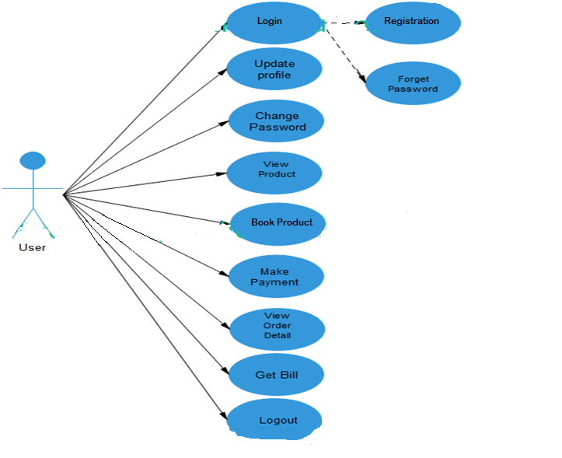

Supplier Use Case:

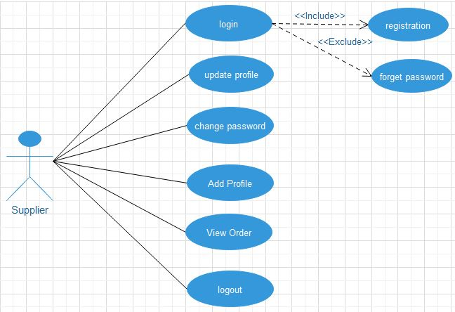Admin Use Case :

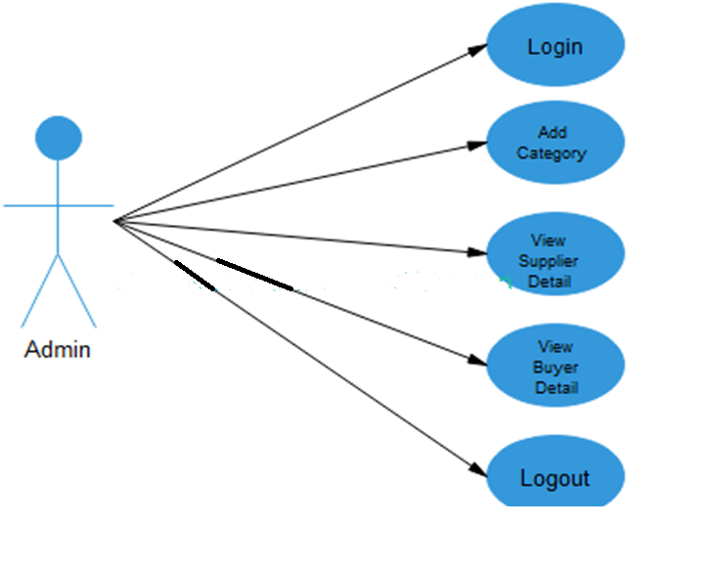

3.2) Class Diagram:

* A class diagram is an illustration of the relationships and [sourcecode](http://searchsoa.techtarget.com/definition/source-code) dependencies among classes in the Unified Modeling Language (UML). In this context, a [class](http://whatis.techtarget.com/definition/class) defines the [method](http://searchcio-midmarket.techtarget.com/definition/method)s and [variable](http://whatis.techtarget.com/definition/variable)s in an [object](http://searchsoa.techtarget.com/definition/object), which is a specific entity in a program or the unit of code representing that entity. Class diagrams are useful in all forms of object-oriented programming (OOP). The concept is several years old but has been refined as OOP modeling paradigms have evolved.
* **Basic Notations used to create Basic Class Diagram.**

|  |  |  |
| --- | --- | --- |
| **Name** | **Symbol** | **Description** |
| Classes |  | Classes represent an abstraction of entities with common characteristics. Associations represent the relationships between classes. Illustrate classes with rectangles divided into compartments. Place the  name of the class in the first partition (centered, bolded, and capitalized), list the attributes in the second partition (left-aligned, not bolded, and lowercase), and write operations into the third. |
| Visibility |  | Use visibility markers to signify who can access the information contained within a class. Private visibility, denoted with a sign, hides information from anything outside the class partition. Public visibility, denoted with a + sign, allows all other classes to view the marked information. |
| Association | - | Associations represent static relationships between classes. Place association names above, on, or below the association line. |
| Multiplicity: | **-** | Place multiplicity notations near the ends of an association. These symbols indicate the number of instances of one class linked to one instance of the other class. |
| Generalization | **-** | Generalization is another name for inheritance or an "is a" relationship. It  refers to a relationship between two classes where one class is a specialized version of another. |

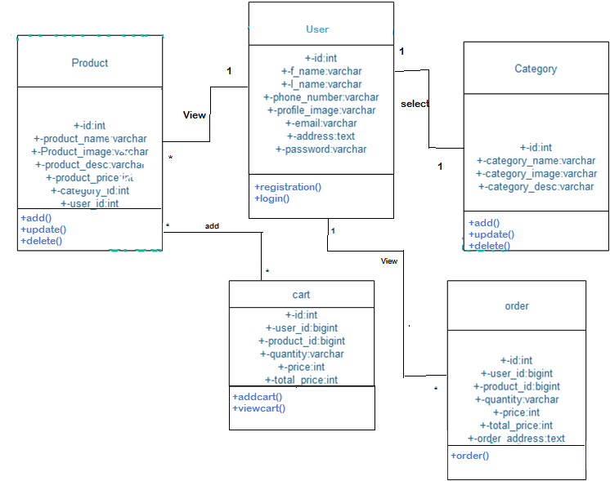

3.3) Activity Diagram:

* Activity diagram is another important diagram in UML to describe the dynamic aspects of the

system. Activity diagram is basically a flowchart to represent the flow from one activity to another activity. The activity can be described as an operation of the system. The control flow is drawn from one operation to another. This flow can be sequential, branched, or concurrent. Activity diagrams deal with all type of flow control by using different elements such as fork, join, etc.

* **Basic Notations used in Activity Diagram:**

|  |  |  |
| --- | --- | --- |
| **Name** | **Symbol** | **Description** |
| Initial (Starting) State:- |  | A small filled circle followed by an  arrow represents the initial action state or the start point for any  activity diagram. |
| Activity/Action State |  | An action state represents the noninterruptible action of objects. You can draw an action state in SmartDraw using a rectangle with rounded corners. |
| Action Flow | - | Action flows, also called edges and paths, illustrate the transitions from one action state to another. They are usually drawn with an arrowed line. |
| Decision and Branching | **-** | A diamond represents a decision with  alternate paths. When an activity requires a decision prior to moving on to the next activity, add a diamond between the two activities. |
| Final State/End Point | **-** | An arrow pointing to a filled circle nested inside another circle represents the final action state.  . |

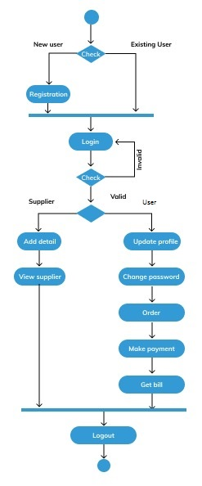

3.4) Interaction Diagram:

* Interaction diagrams describe interactions among classes in terms of an exchange of messages

over time. They're also called event diagrams. A sequence diagram is a good way to visualize and

validate various runtime scenarios. These can help to predict how a system will behave and to discover

responsibilities a class may need to have in the process of modeling a new system.

* **Basic Notations used in interaction diagram:**

|  |  |
| --- | --- |
| **Name** | **Description** |
| Class Roles or Participants | Class roles describe the way an object will behave in context. Use the UML object symbol to illustrate class roles, but don't list object attributes. |
| Activation or Execution Occurrence | Activation boxes represent the time an object  needs to complete a task. When an object is busy executing a process or waiting for a reply message, use a thin gray rectangle placed vertically on its lifeline. |
| Messages | Messages are arrows that represent communication between objects. Use halfarrowed lines to represent asynchronous messages. Asynchronous messages are sent from an object that will not wait for a response from the receiver before continuing its tasks. For message types, see below.  - |
| LifeLines | Lifelines are vertical dashed lines that indicate the object's presence over time.  **-** |

Interaction diagram of User login:

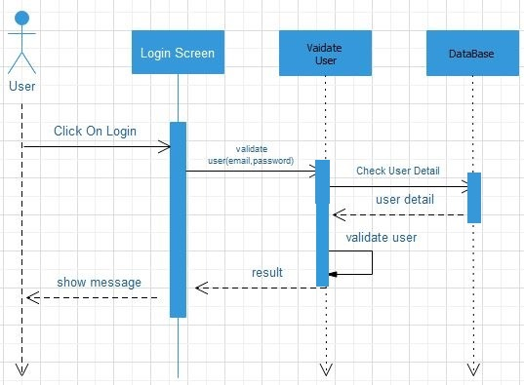

Interaction diagram of Product Page:

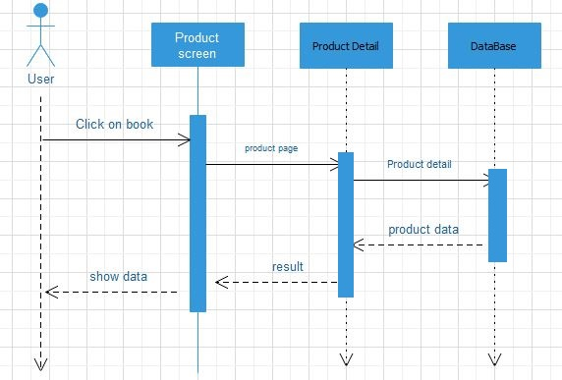

Interaction diagram of Checkout:

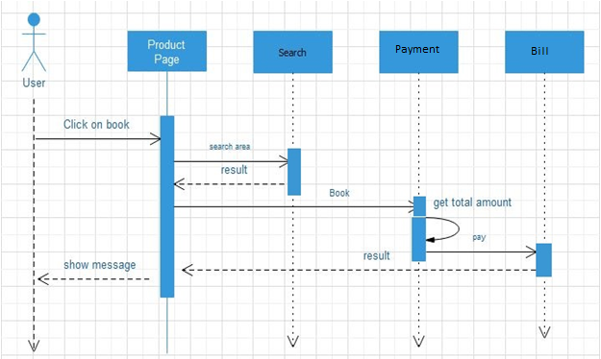

Interaction diagram of Supplier login:

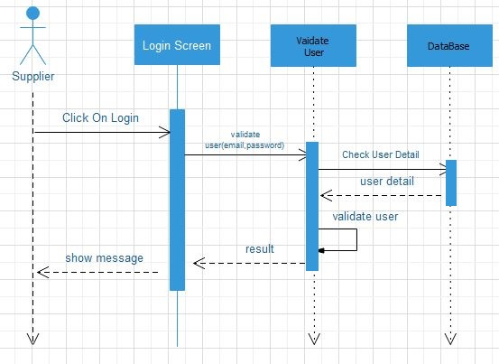

3.5) Data Dictionary:

* **What is Data Dictionary?**

A data dictionary is a file or a set of files that contains a database’s metadata or schema of andatabase. The Data Dictionary contains records about other objects in the database, such as dataownership, data relationships to other data.

The Data dictionary is a crucial component of any relational database. Ironically, because of itsimportance, it is invisible to most database users. Typically, only database administrators interact withthe data dictionary.

* **Why Data Dictionary is Important?**
* **In order to manage the details in large-scale systems:-**Most systems are ongoingand dynamic and management of all the descriptive details is difficult, therefore an accurateand consistent recording technique is essential.
* **To communicate a common meaning for all of the elements in the system**:- Simply makingsure that for all elements, the meaning will remain consistent.
* **To document features of the system:-**It is essential to document the circumstances underwhich data items occur. For example, what is the frequency of this process? Who has access tothis datastore? Documenting these features will produce a more complete and betterunderstanding of the system for the analyst.
* **To locate errors and omissions in the system:-**The data dictionary may reveal informationthat is incomplete and/or inaccurate. It may show stores that are never accessed and/orprocesses that should be sub-divided, etc.

1) Table: users

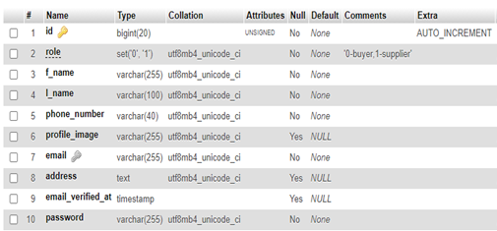

2) Table: product

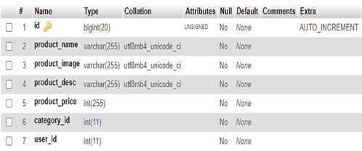

3) Table: password_reset

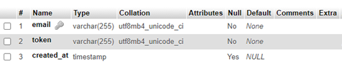

4) Table: migration

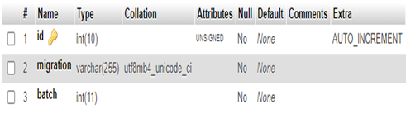

5) Table: failed_jobs

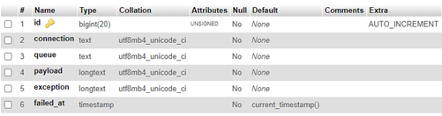

6) Table: order

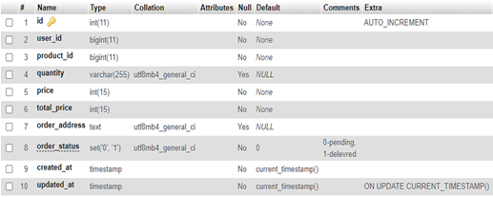

7) Table: categories

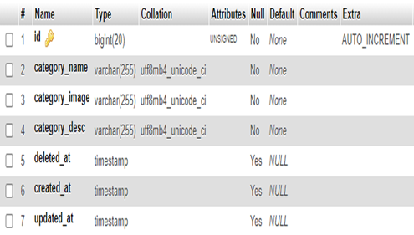

8) Table: cart

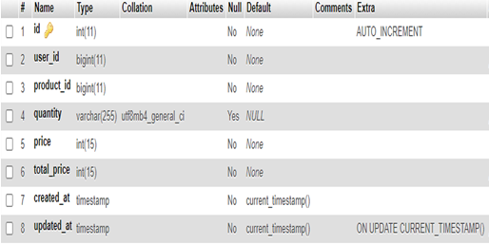

4) Development

4.1) Coding Standard:

* Every Company follows a different coding standard based on their best practices. Coding standards is required because there may be many developers working on different modules so if they will start inventing their own standards then source will become very un-manageable and it will become difficult to maintain that source code in future.
* **In this system i am also following coding standards as below.**
* Php tag start <?php not used short form like <?.
* Comment is used between <!--> …--> and // not used #.
* For Header and footer create one php page and after that include in all pages using include().
* Tthe fields of id’s of the table is prefix used Autoincrement.
* All function are declare in bottom of code using <script>.
* Declare variable using $ sign.**Example** var $varname= value.
* In different form submit using Post method because in this method it will not show information in another page in Get method it provide information show in another page.
* simple and manageable manner so it will become easy to manage andunderstand.

4.2)Screen Shots

1) Home Page

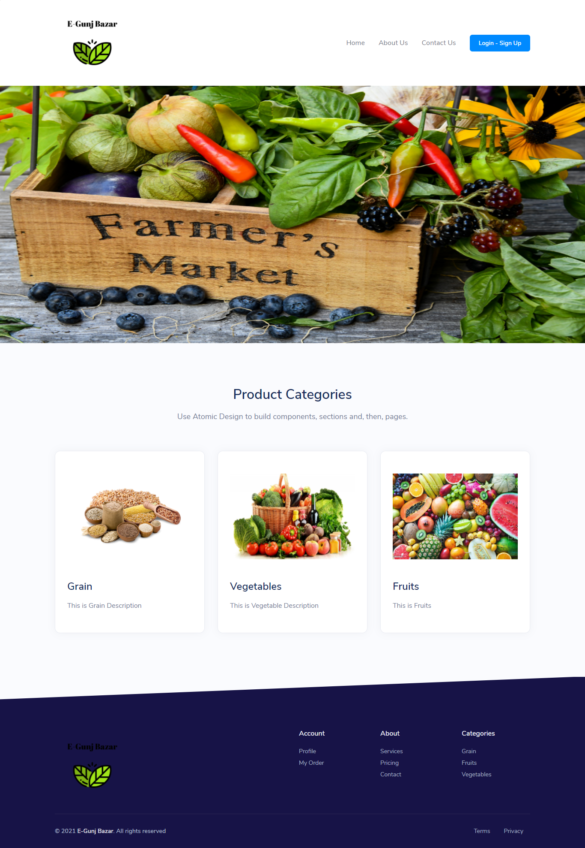

2) Registration Page for supplier

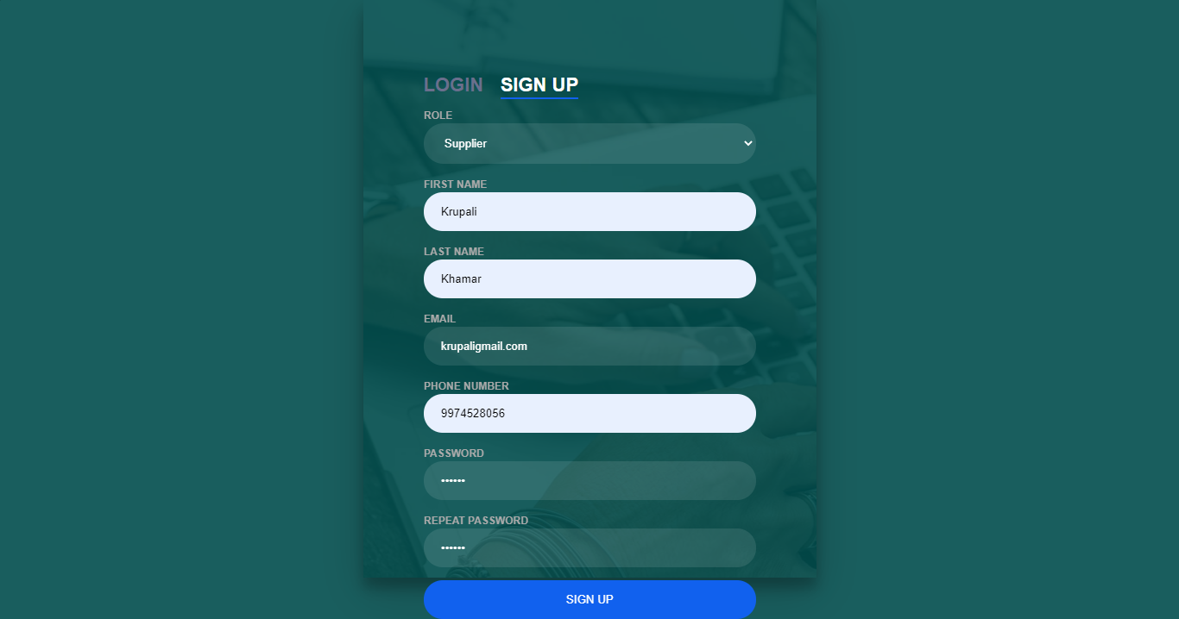

3) Registration page with validation

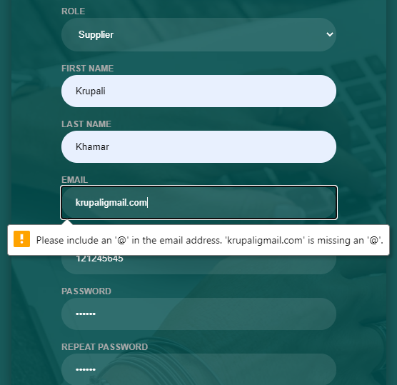

4) Login Page

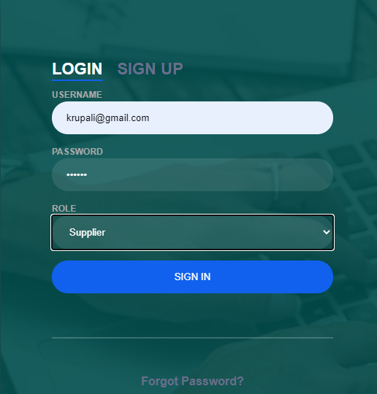

5) Login page with validation

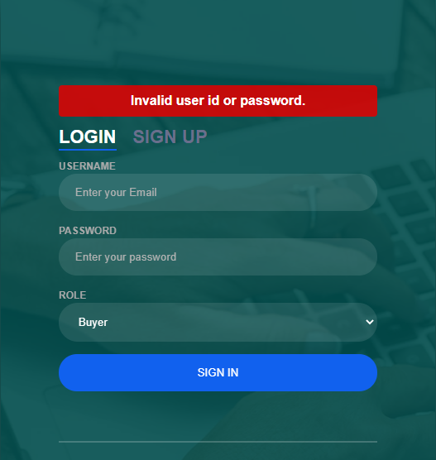

6)Supplier Home Page

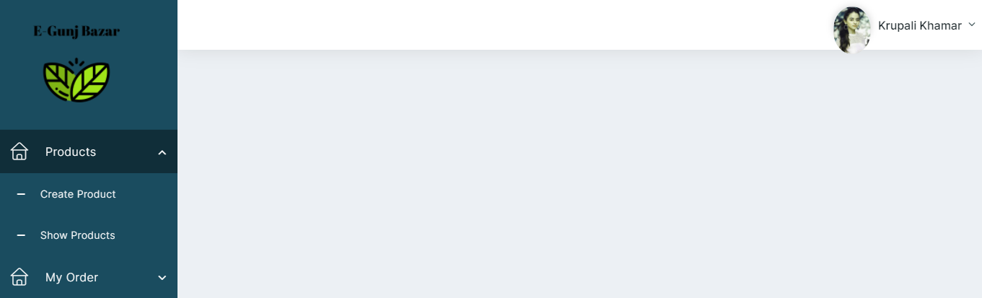

7) Create Product

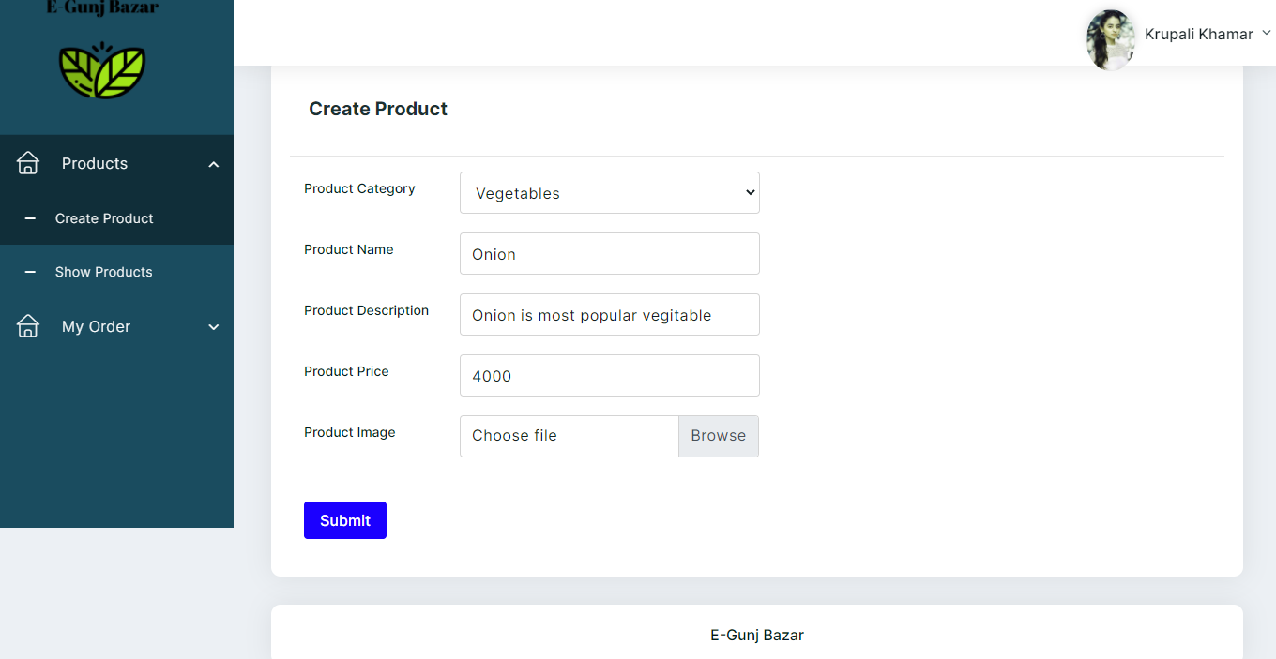

8) Show Product

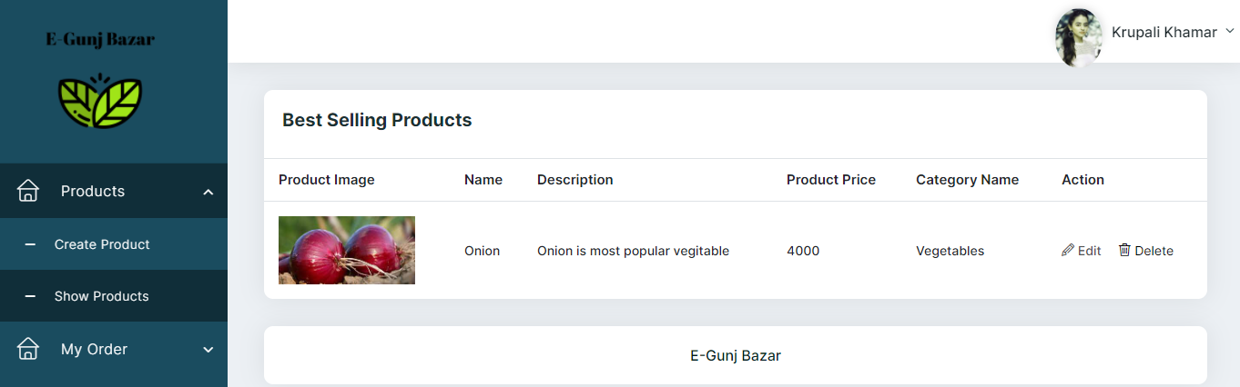

9) Update Products

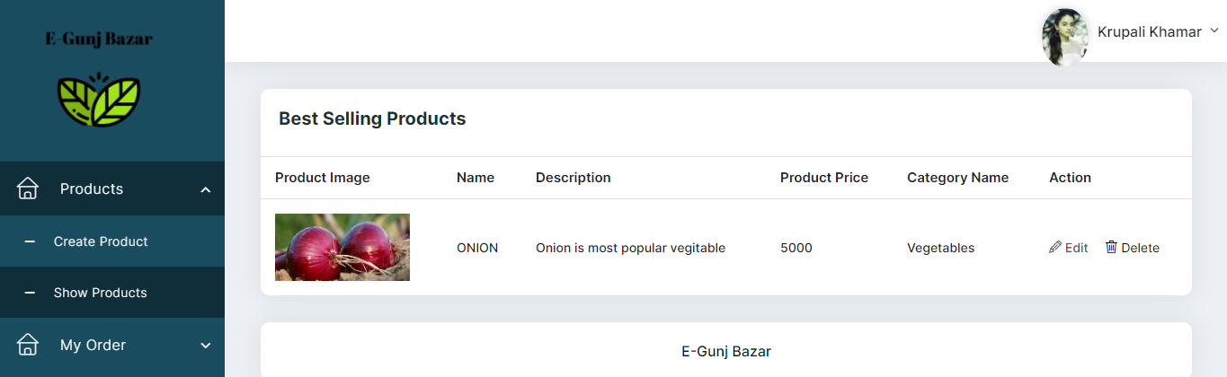

10) Confirmation Message For Delete product

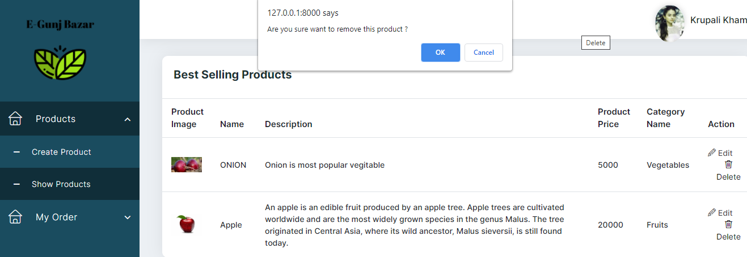

11) Delete Product

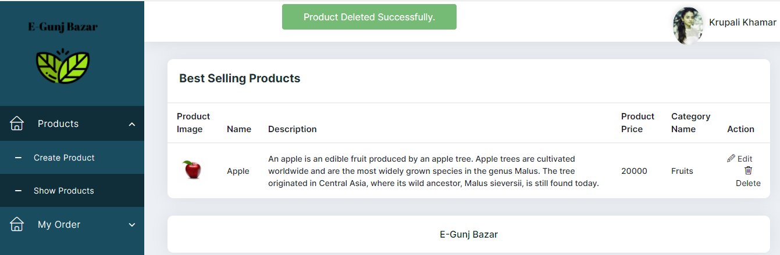

9) Supplier Profile

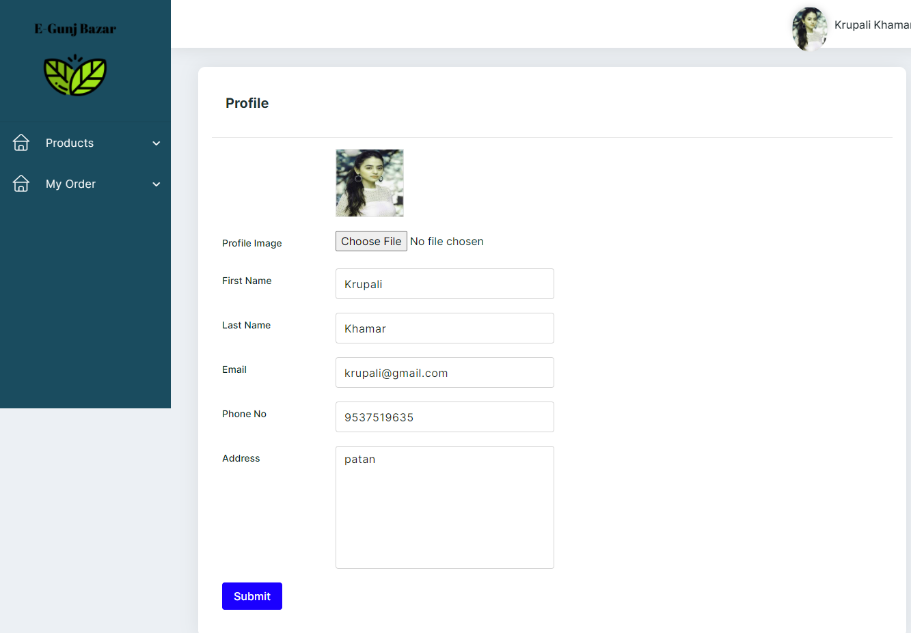

12) Update Password

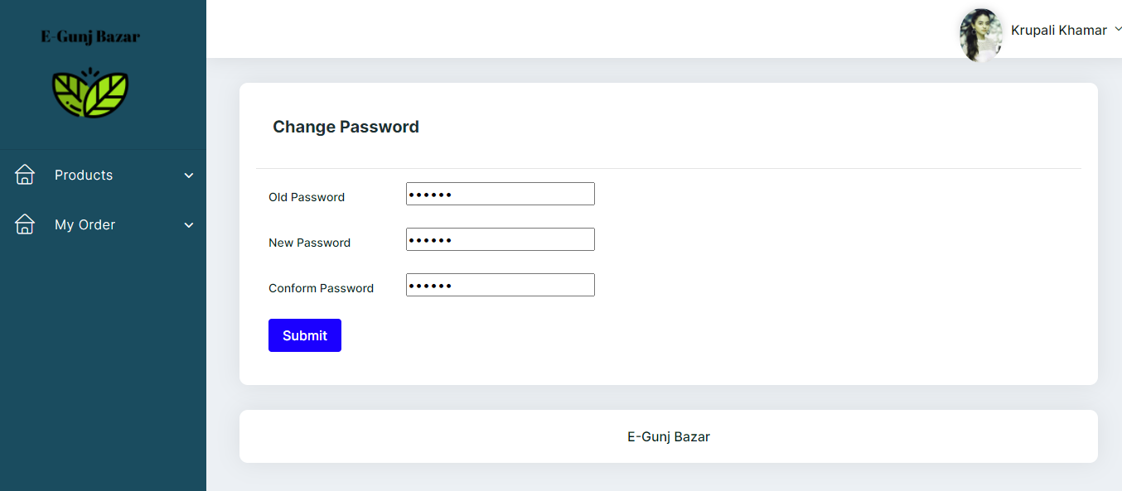

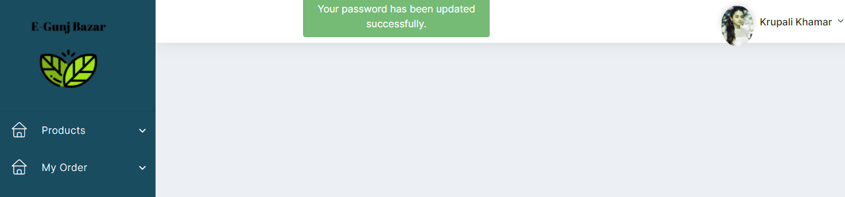

10) Admin Home page

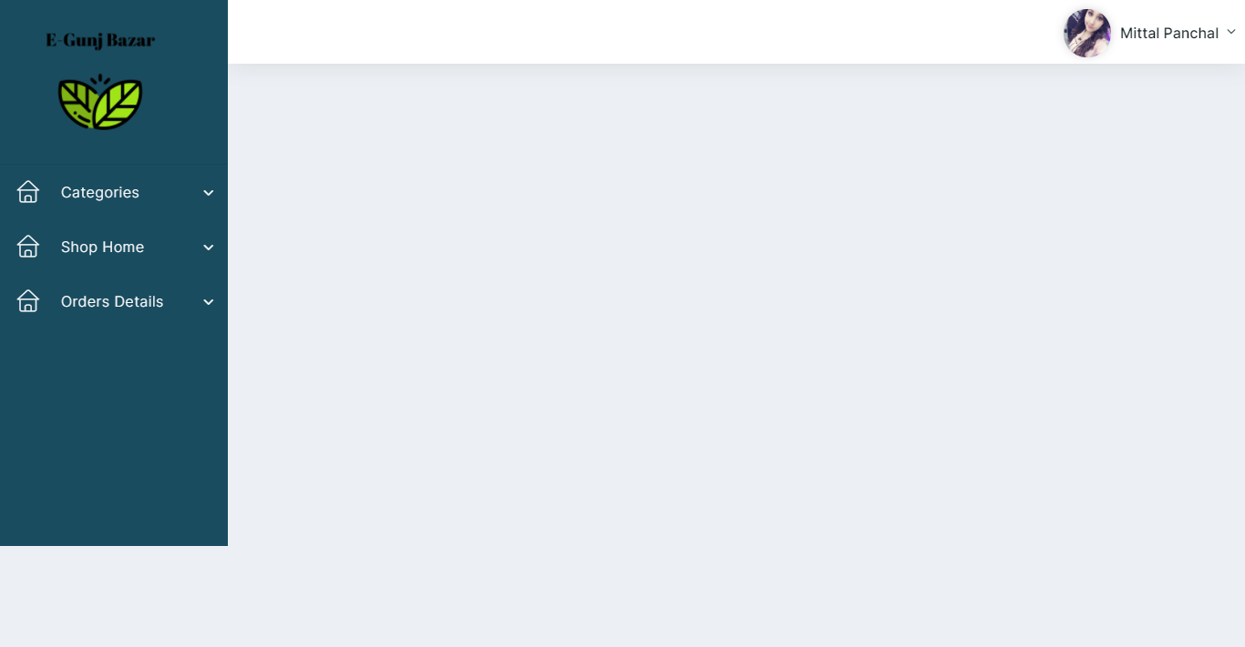

11) Admin Add Category

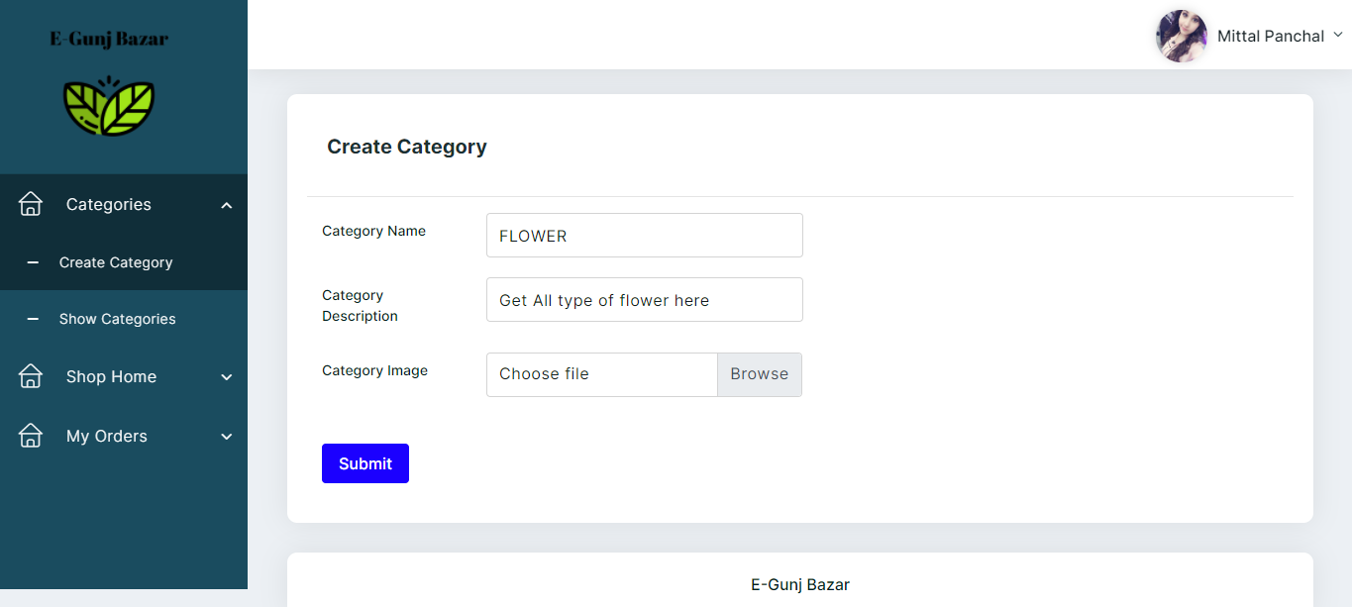

12) Category Added Successfully

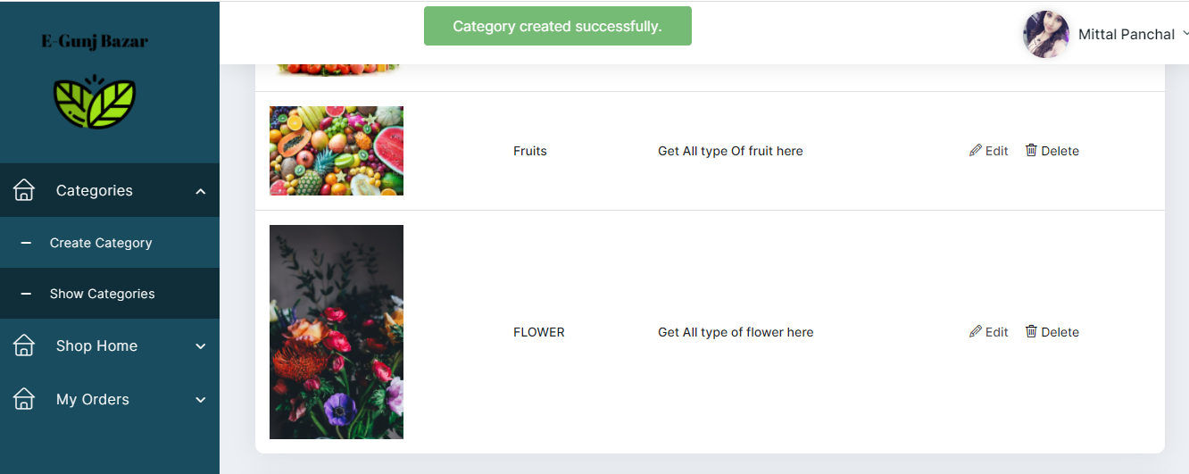

13) Admin View Category

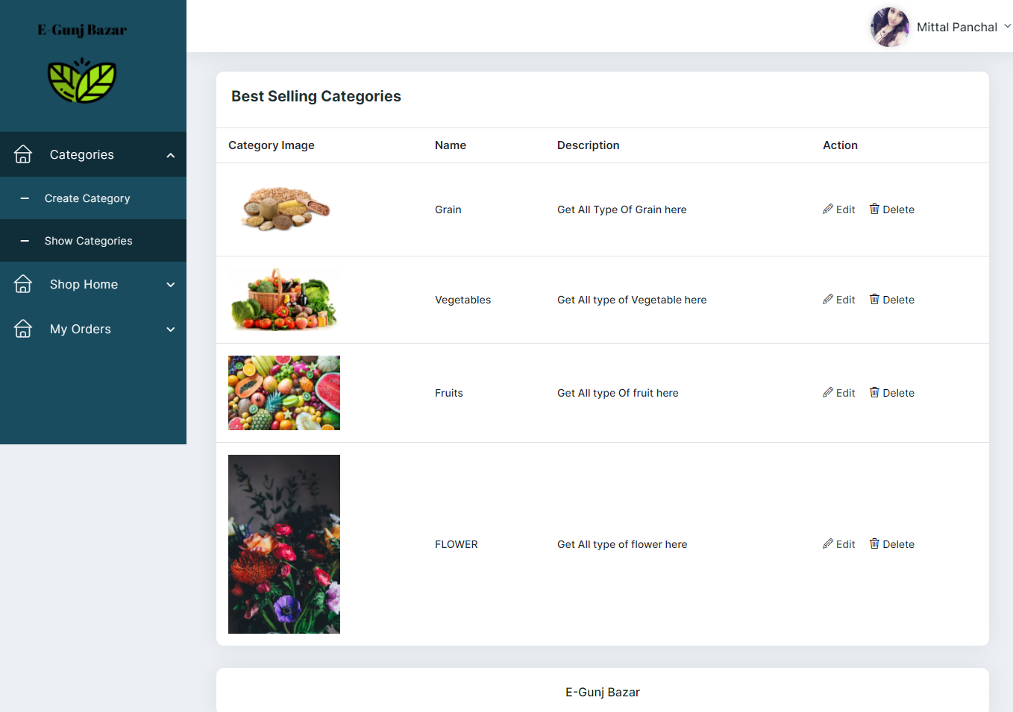

13) Admin Can Delete Category

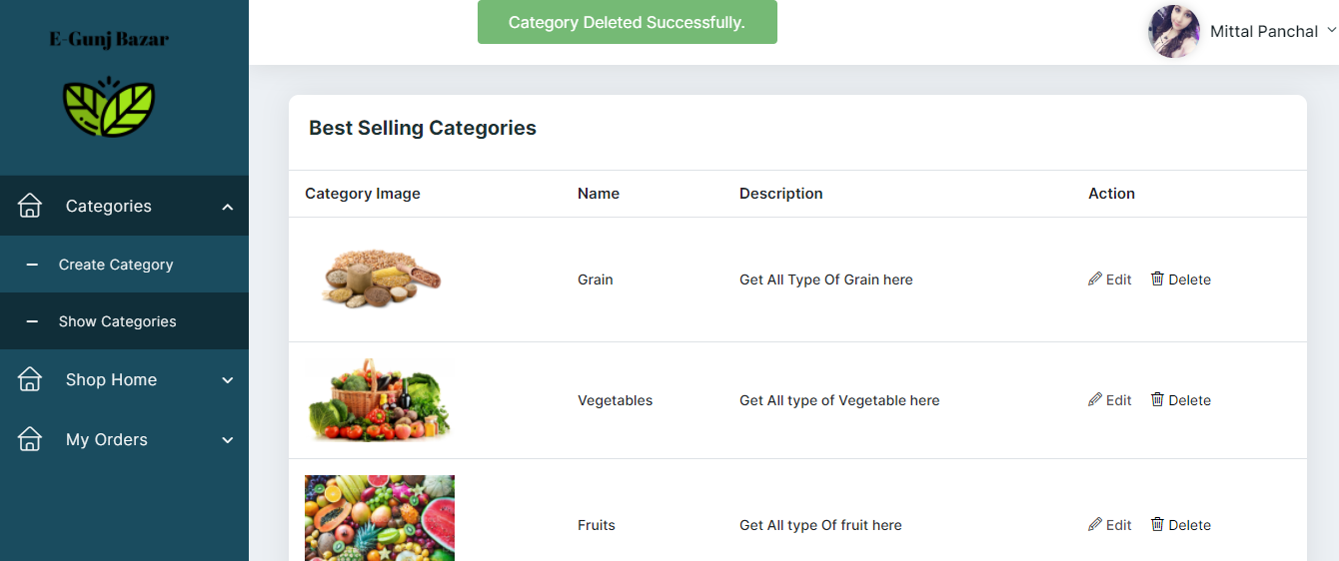

14) Admin Can Show All Order

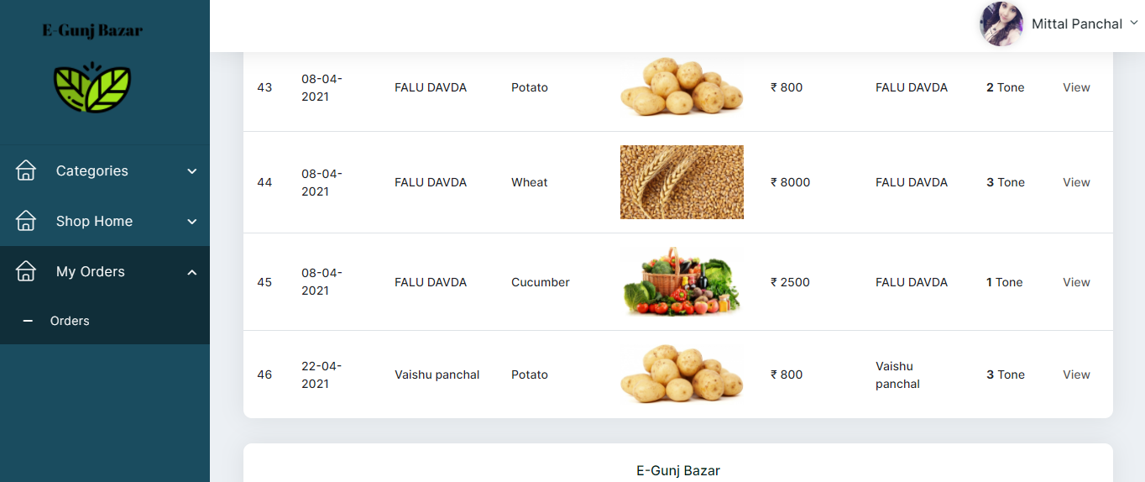

15) Buyer Registration Page

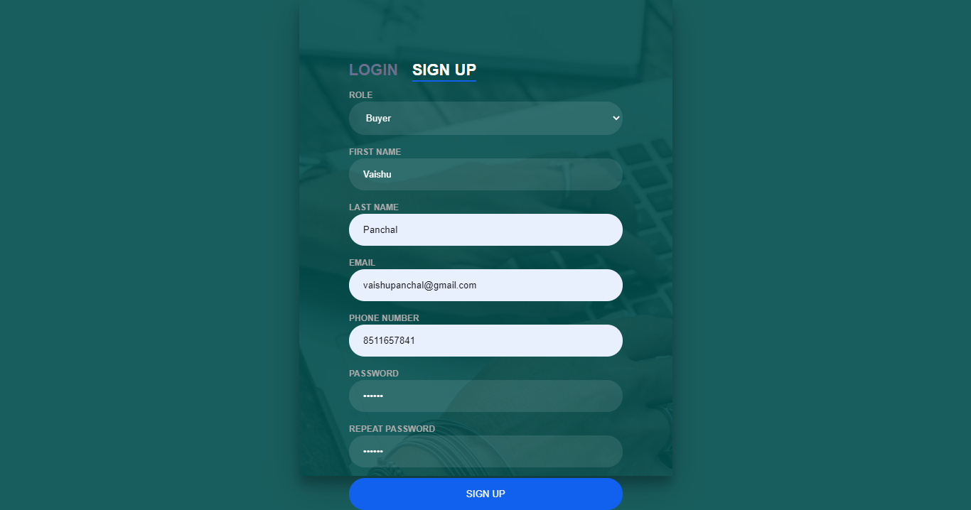

16) Buyer Registrations Page with Validation

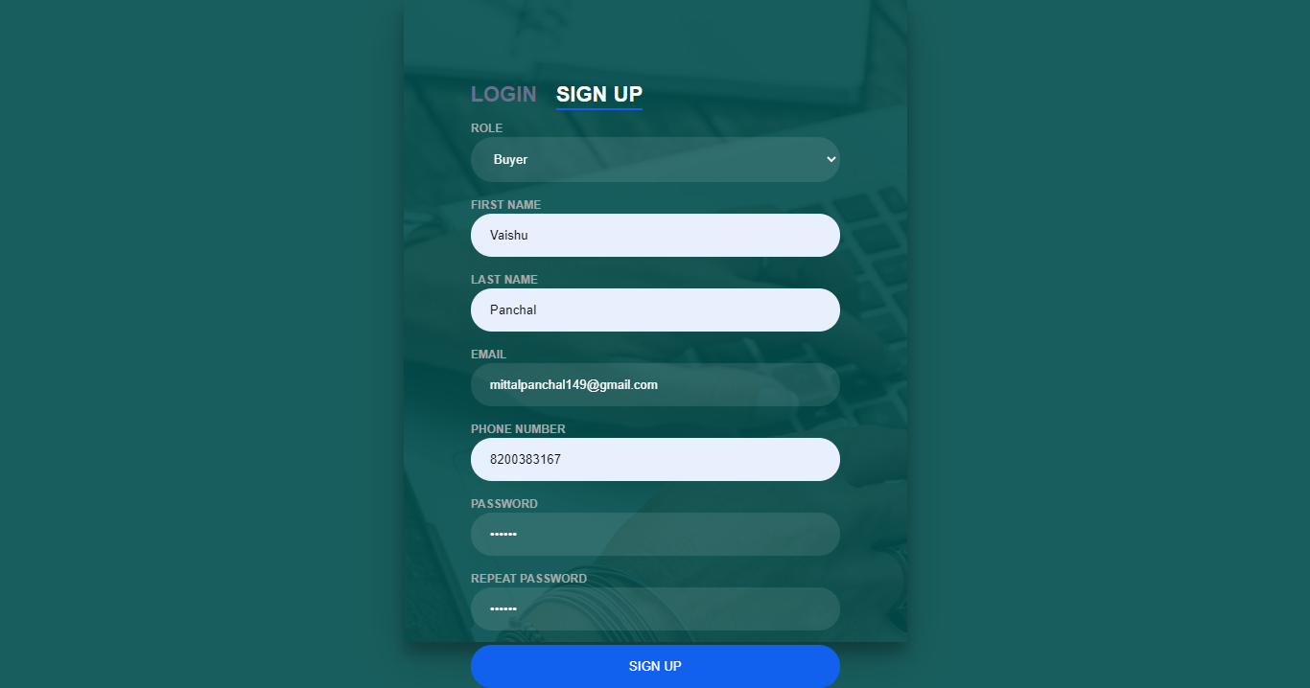

17) Buyer Login Page

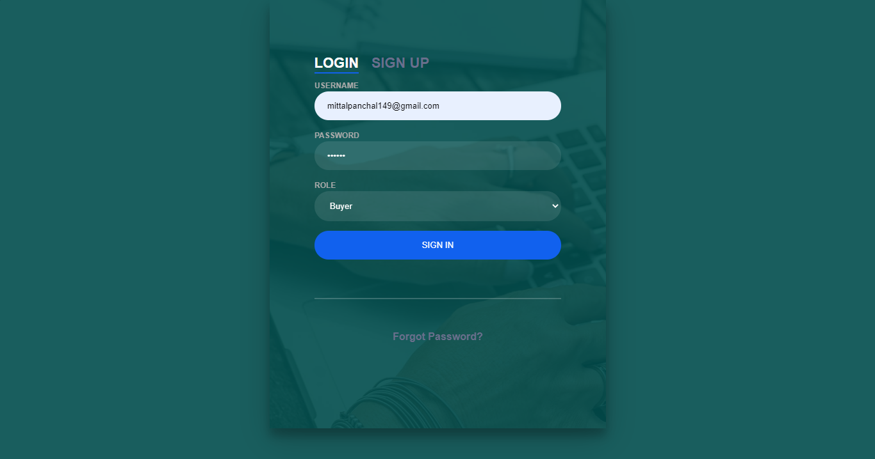

18) Buyer Home Page

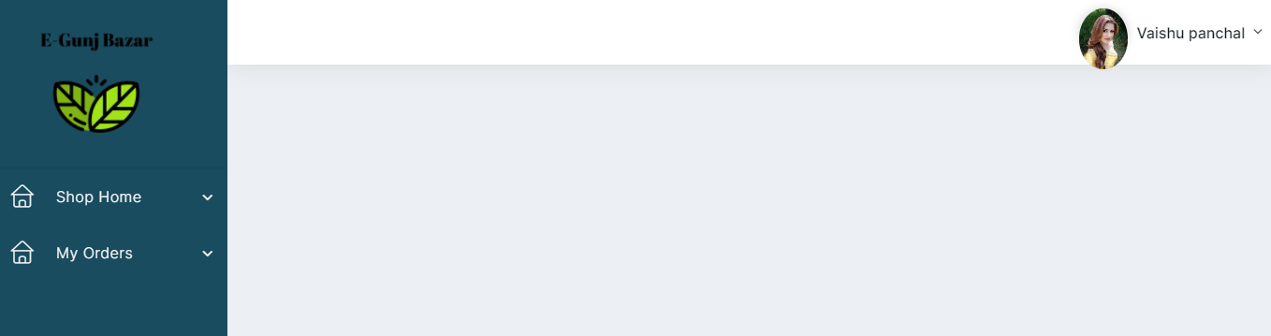

19) Buyer Can See Product Description

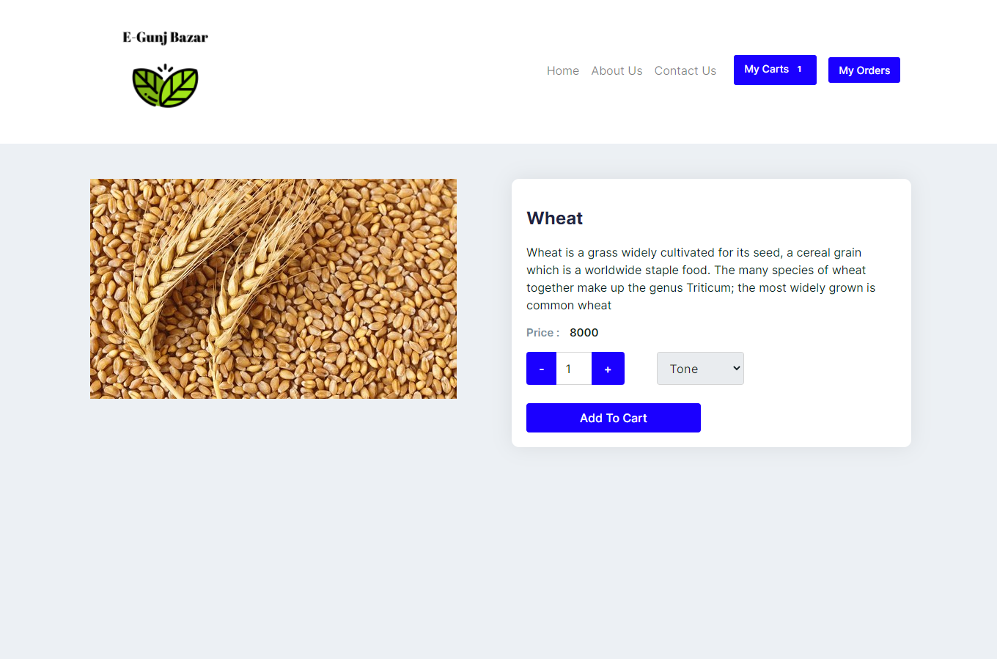

20) Buyer Can Add To Cart & Show Cart

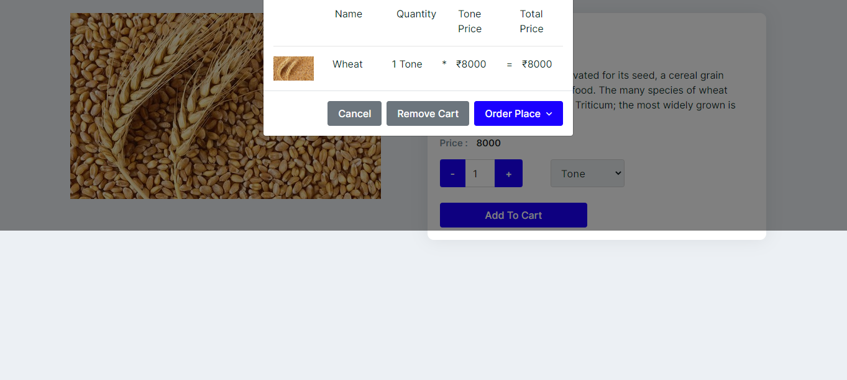

21) Buyer Cam Remove Item from Cart

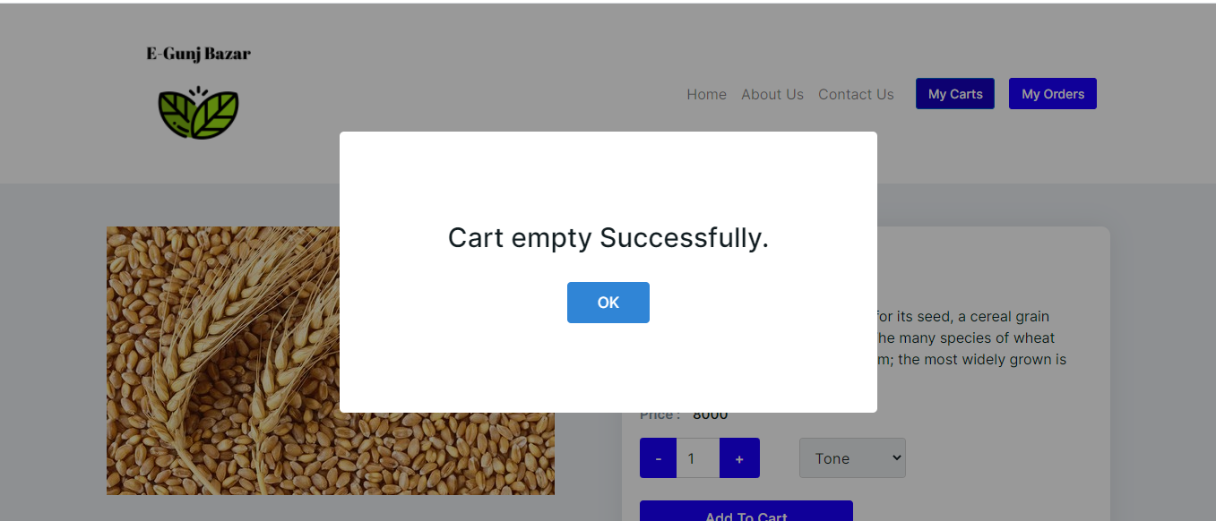

22) Click For Place an Oder

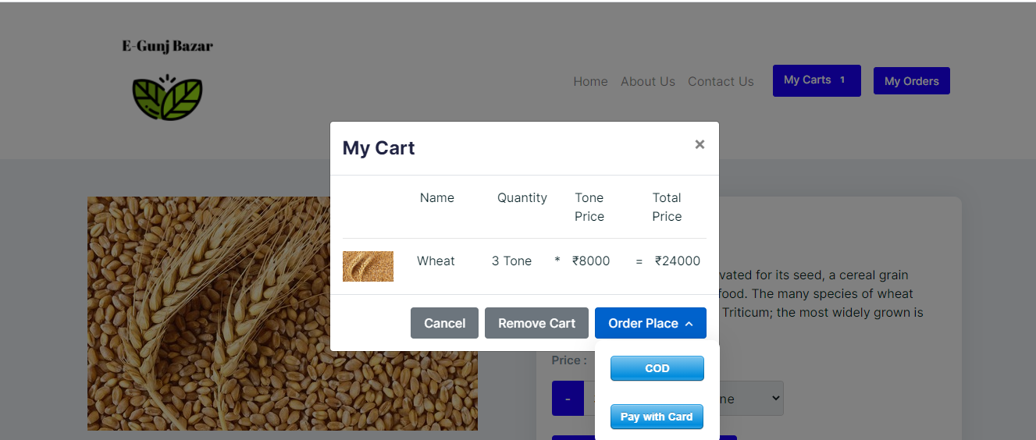

22) Payment With Gateway

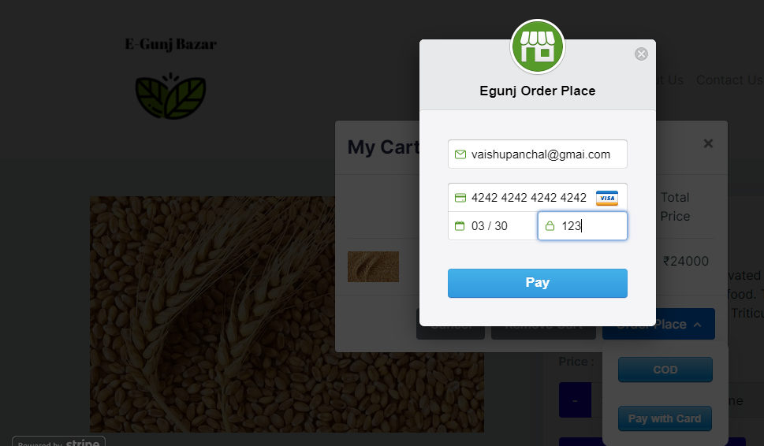

23) Payment Successfully

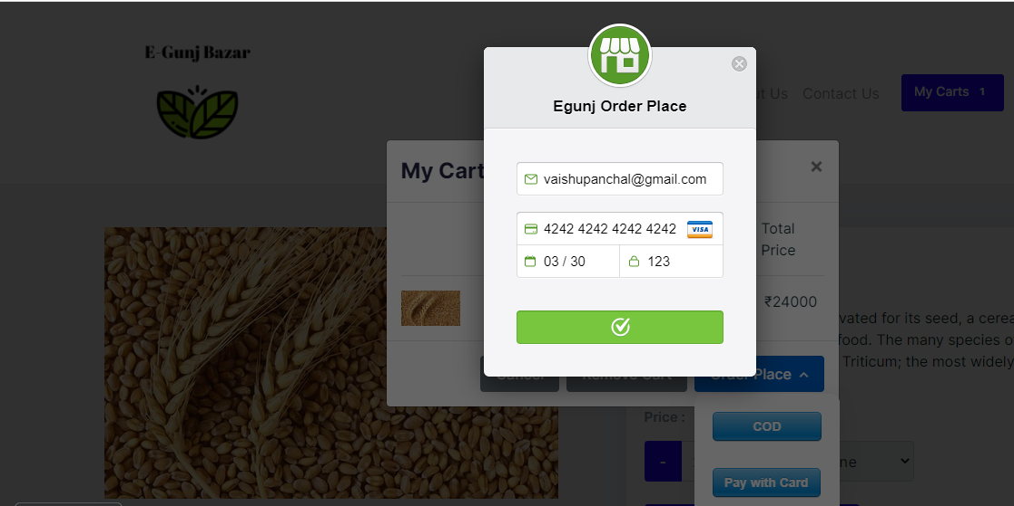

24)Mail Sent Successfully Place Order

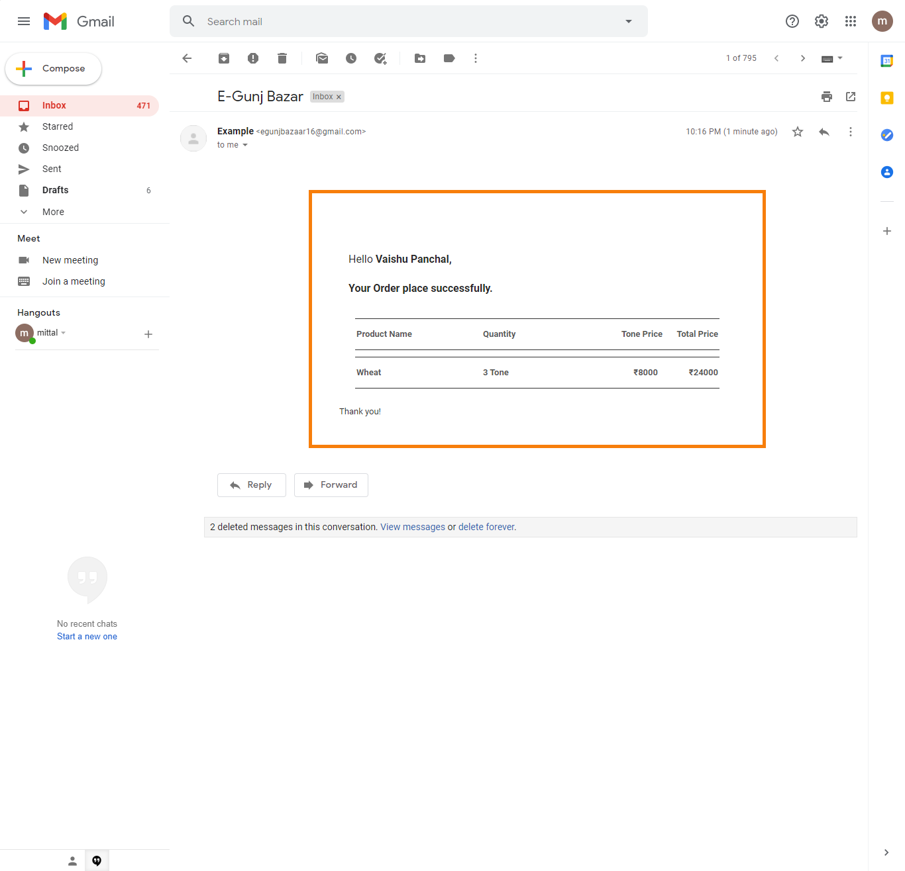 25) Buyers Can View Order

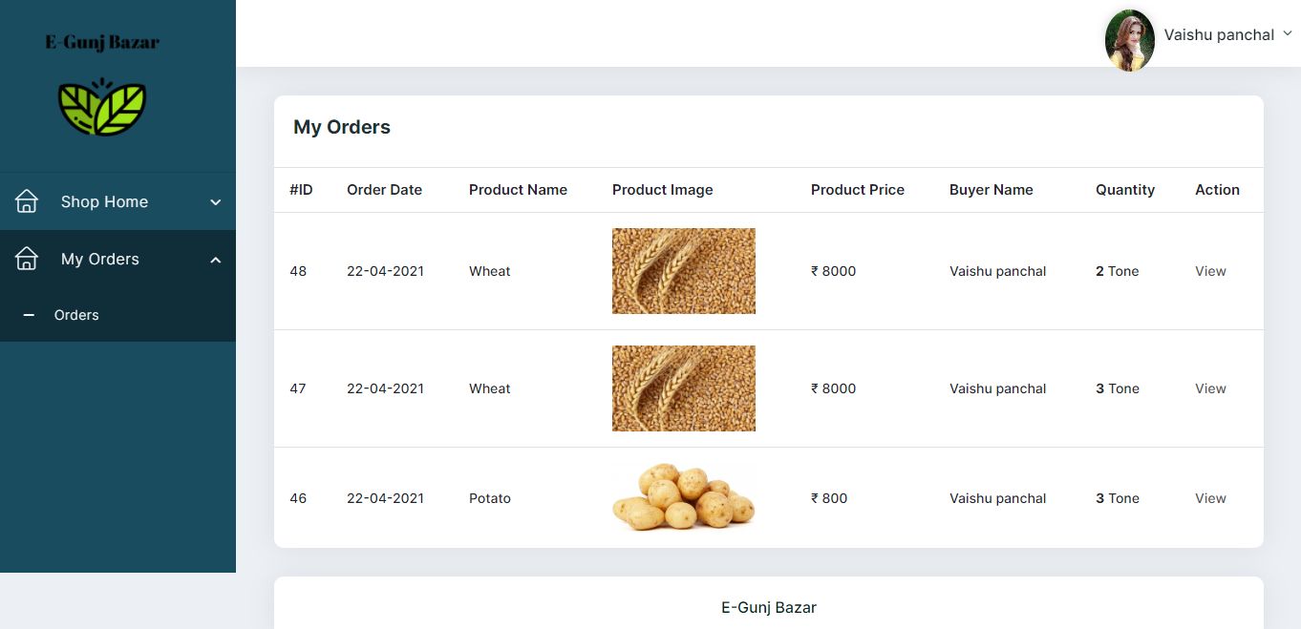

26) Buyer Can Update Profile

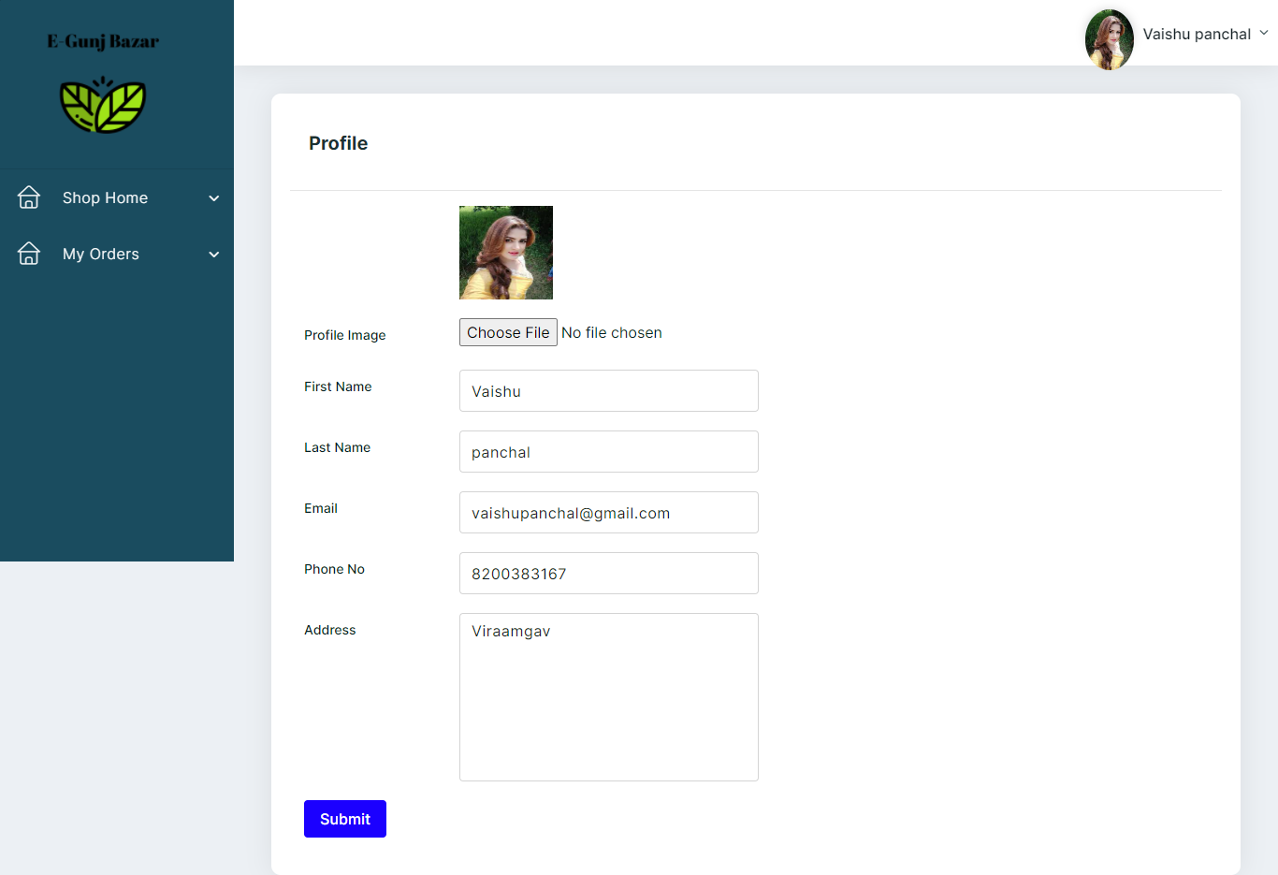

27) Profile Updated Successfully

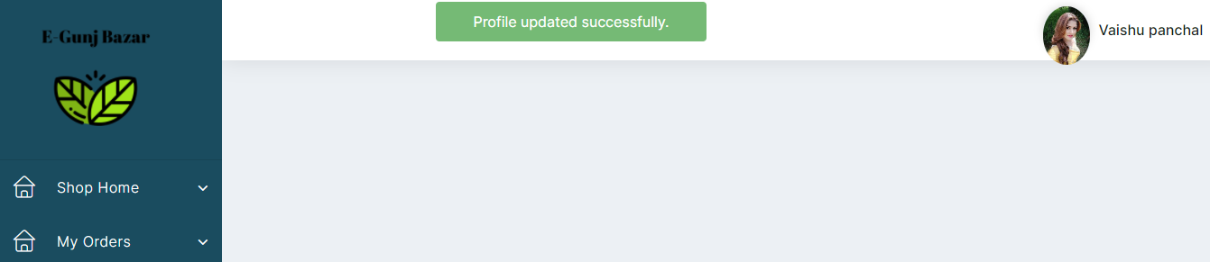

28) Contact Us

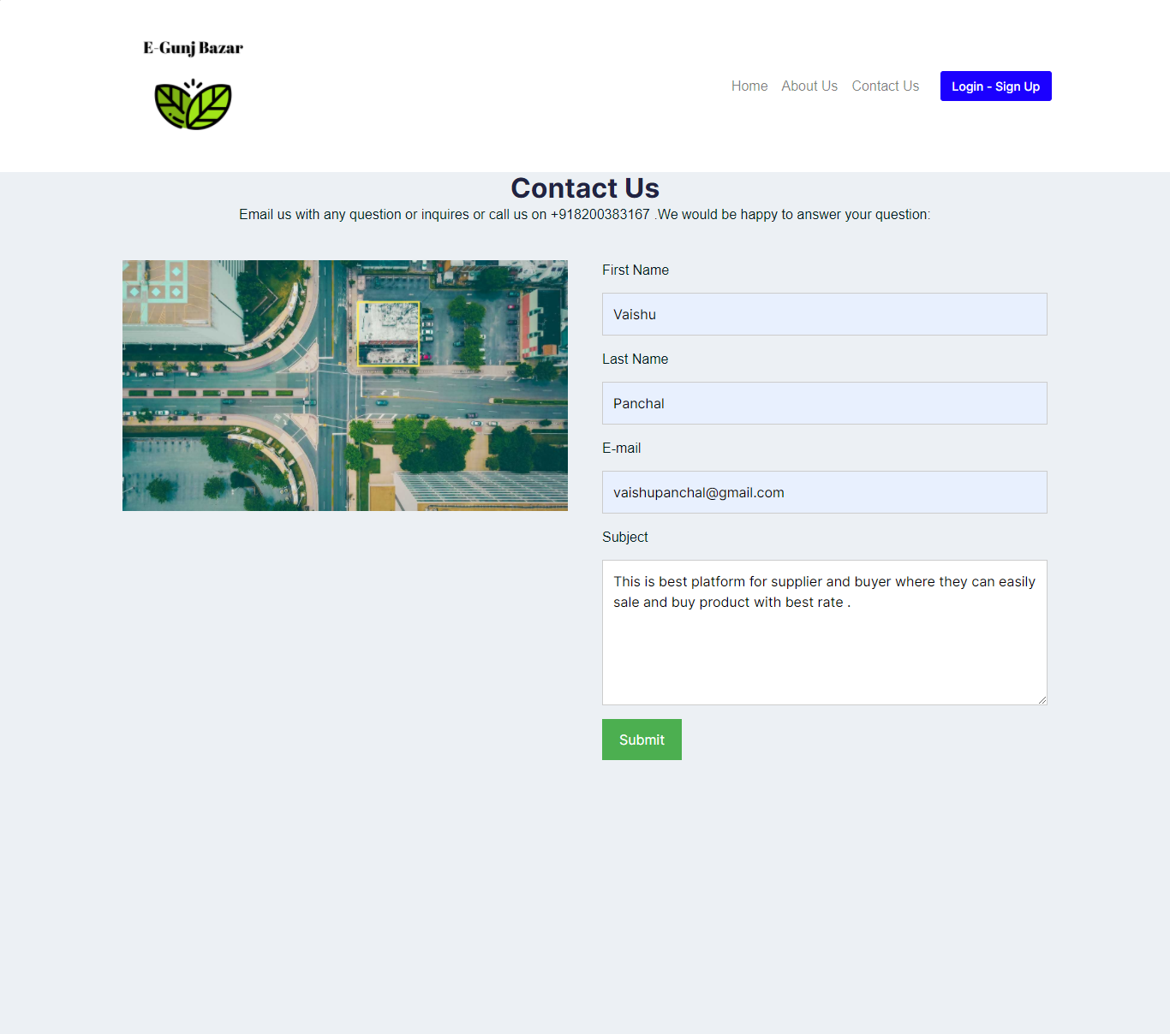

29) About US

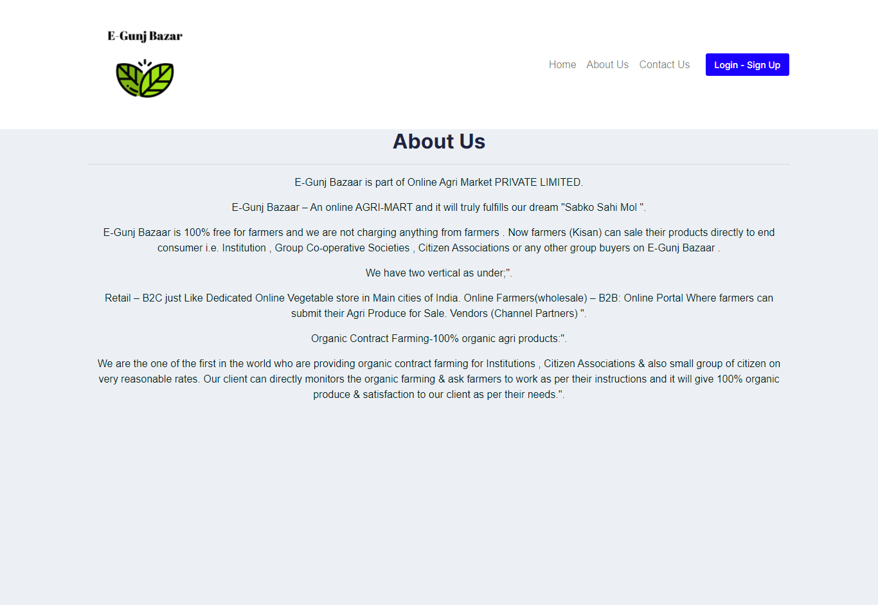

5) Agile Document

* Agile is a software development methodology to build a software incrementally using short iterations of 1 to 4 weeks so that the development is aligned with the changing business needs. Instead of a single-pass development of 6 to 18 months where all the requirements and risks are predicted upfront, Agile adopts a process of frequent feedback where a workable product is delivered after 1 to 4 week iteration.
* Agile software development is an approach to software development under which requirements and solutions evolve through the collaborative effort of self-organizingand cross-functional teams and their customers or end users.It advocates adaptive planning, evolutionary development, empirical knowledge, an continual improvement, and it encourages rapid and flexible response to change.
* 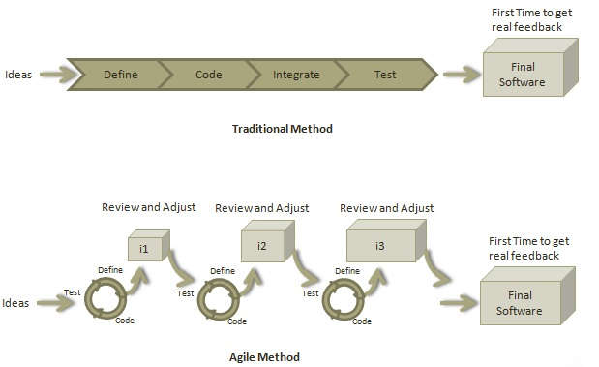In this project, we used the agile methodology. At first we receive all the majorrequirements so after that , all feasibility is checked for the project .Initially deadline and budget is decided but if there are minor requirement changes then we accept that change and extending deadline is allowed if change is major.

5.1) Agile Project Charter:

* A document issued by the project initiator or sponsor that formally authorizes the existence of a project, and provides the project manager with the authority to apply organizational resources to project activities.

The project charter is the most important document you will create in a project and it is essential that all stakeholders participate in its creation. It balances intentions, aligns stakeholders and provides an agreed upon definition of what success looks like. Although the charter is only one page long, it can be a challenging piece of work to craft an effective document.

* **An Agile Charter has three primary components:**
  1. **Vision: -** The vision defines the “Why” of the project. This is the higher purpose, or the reason for the project’s existence.
  2. **Mission: -** This is the “What” of the project and it states what will be done in the project to achieve its higher purpose.
  3. **Success Criteria: -** The success criteria are management tests that describe effects outside of the solution itself.

**Name Of Team :-**

|  |  |  |  |  |  |
| --- | --- | --- | --- | --- | --- |
| **Chartering group** | **Sponcer** | **Team Leader** | **Facilitator** | **Target Completion Date** | **Actual completion Date** |
|  |  |  |  | April 09,2021 | Apr 14,2021 |

|  |  |
| --- | --- |
| **Mission Statement** | “E-Gunj Bazaar”is Web application.  This application developed for Online Organic Product.  It provides water and water related services. |
| **Goals & Objectives** | The goal of “E-Gunj Bazaar” is to develop an application which is provide water online. E-Gunj Bazaar Provide Organic Grain and vegetable and fruits in all over India .   * View Product. * Add Quantity. * User can pay online. * View user’s order details. |
| **Customers** | Every customer can view product and purchase product. Customer  Can get payment online using credit card or payTm. |
| **Success Indicators** | Number of user who registerd are maintain their profile or update data.  Supplier can modify Product details. |

|  |  |  |
| --- | --- | --- |
| **E-Gunj Bazaar System** | | |
| **Date Charted** | **Target Completion Date** | **Actual Completion Date** |
| Oct 15th ,2024 | Jan 30th 2024 | Jan 25th ,2024 |
| **Team Members** | | |
| Panchal Mittal | | |

5.2) Agile Roadmap:

A product roadmap is a plan of action for how a product or solution will evolve over time. Product owners use roadmaps to outline future product functionality and when new features will be released. When used in agile development, a roadmap provides crucial context for the team's everyday work, and should be responsive to shifts in the competitive landscape. Multiple agile teams may share a single product roadmap.

To build a roadmap, product owners take into account market trajectories, value propositions, and engineering constraints. Once these factors are reasonably well-understood, they are expressed in a roadmap as initiatives and timelines. Below is a very simple road mapfor a product team. The initiatives are in blue and timelines are indicated by the milestone markers in red.

|  |  |  |  |
| --- | --- | --- | --- |
| **Oct 2023,Q1** | **Nov 2023,Q2** | **Dec 2023,Q3** | **Jan 2024,Q4** |
| **Tasks:-**   1. Requirements Gathering. 2. Database Design. 3. Template Integration. 4. Registration pages   Template Integration.   1. Check Registration in database. 2. Create Login template using Template integration. 3. Check Login in database. | **Tasks:-**   1. Create user dashboard. 2. Create different services page. 3. Create Supplier Dashboard. 4. Create water tanker and can page. 5. Check Tanker and can detail in database query. 6. View water tanker page at user side manually. 7. Create Contact Us page for send feedback. 8. Check user feedback at user side. | **Tasks:-**   1. Create User Change password page. 2. Modify user password. 3. Create User profile page. 4. Modify user profile. 5. View registered user in a supplier side. 6. Create Cleaning Service page. 7. Create Search page 8. Create checkout page for fill information of user’s details. 9. Make payment page with different option. 10. View order detail in user side. | **Tasks:-**   1. Improvements. 2. QA Reviews. |
| **Goal:-**  Grow 10% of userin this quarter by reducing churm from a more reusable component. | **Goal:-**  In this quarter add water tanker and can page in user side and database. | **Goal:-**  Add cleaning service page and search with checkout and payment different option. | **Goal:-**  QA reviews to solve the bugs and solve the error of application. |
|  |  |  |  |

5.3) Agile Project Plan :

Agile release planning differs from traditional project planning in that it is based on a selection of features that are developed during a specific set of time (the sprint). The ultimate purpose of Agile release planning is to achieve the product vision - the high-level goal for the product and how it aligns with a business strategy. An Agile project’s release plan is the all-encompassing timetable focused on planning multiple iterations in an effort to determine when each release will be delivered. In order toachieve the product vision, there are several details to consider prior to building a release plans,including:

* Availability of the product owner
* Prioritized backlog that has been reviewed by the product owner
* Identified team members and stakeholders
* Team member locations and availability

|  |  |  |  |  |  |  |  |  |  |  |  |  |  |  |  |  |
| --- | --- | --- | --- | --- | --- | --- | --- | --- | --- | --- | --- | --- | --- | --- | --- | --- |
| **Project Plan Of E-Gunj Bazaar System** | | | | | | | | | | | | | | | | |
| **Phase** | **Month (January)** | | | | **Month(February)** | | | | **Month(March)** | | | | **Month (April)** | | | |
| UI controls |  |  |  |  |  |  |  |  |  |  |  |  |  |  |  |  |
| UI Design |  |  |  |  |  |  |  |  |  |  |  |  |  |  |  |  |
| Database Design |  |  |  |  |  |  |  |  |  |  |  |  |  |  |  |  |
| Strategy |  |  |  |  |  |  |  |  |  |  |  |  |  |  |  |  |
| Planning |  |  |  |  |  |  |  |  |  |  |  |  |  |  |  |  |
| Project UI Design |  |  |  |  |  |  |  |  |  |  |  |  |  |  |  |  |
| Add Category page |  |  |  |  |  |  |  |  |  |  |  |  |  |  |  |  |
|  |  |  |  |  |  |  |  |  |  |  |  |  |  |  |  |  |
| Add Product page |  |  |  |  |  |  |  |  |  |  |  |  |  |  |  |  |
| Search page |  |  |  |  |  |  |  |  |  |  |  |  |  |  |  |  |
| Checkout and Confirmation page |  |  |  |  |  |  |  |  |  |  |  |  |  |  |  |  |
| Payment options and get payment |  |  |  |  |  |  |  |  |  |  |  |  |  |  |  |  |
| QA Testing |  |  |  |  |  |  |  |  |  |  |  |  |  |  |  |  |
| Bugs Solving |  |  |  |  |  |  |  |  |  |  |  |  |  |  |  |  |
| Final Testing |  |  |  |  |  |  |  |  |  |  |  |  |  |  |  |  |

5.4) Agile User Stories:

User stories are part of an agile approach that helps shift the focus from writing about requirements to talking about them. All agile user stories include a written sentence or two and, more importantly, a series of conversations about the desired functionality.

**What is a User Story?**:-

User stories are short, simple descriptions of a feature told from the perspective of the person who desires the new capability, usually a user or customer of the system. They typically follow a simple template:

- As a < type of user >, I want < some goal > so that < some reason >.

1. As a **User,**I want **Grain Online Organic Grain**  so that **i do not go out to Gunj Bazaar.**
2. As a **Supplier(Farmer),** I want **to Sale my product with best rate**  so that **i can take more customer and get best rate .**
3. As a **visiter,** I want **to check online organic grain product and cost** so that **i can view and check.**

5.5) Agile Release Plans:

* Planning and estimating in the agile world depend on a single key metric: the development team’s velocity, which describes how much work the team can get done per iteration. (We describe velocity in detail separately.) Given a team’s known velocity for its last project (if it is known), a release plan represents how much scope that team intends to deliver by a given deadline.
* Releases typically range between 2 and 12 months. For longer releases, it may makesense to break it down into several sub-releases.
* For smaller teams, it may make sense for the entire cross-functional team to participate for both input and accountability purposes. For larger teams and organizations, a subset of the team may be selected or elected to represent the team.

|  |  |  |  |  |  |  |  |
| --- | --- | --- | --- | --- | --- | --- | --- |
|  |  |  |  |  |  |  |  |
| **Sprint** | **Task** | **Start** | **End** | **Duration** | **Status** | **Release Date** | **Goal** |
| 1 | Splash | 10-Jan-2020 | 21-Jan-21 | 11 Days | Completed | 21-Jan-21 | Easy to show Designing |
| Screen, |
| Login, Registration & Forgot Password |
|  |
| 2 | All Product Page | 21-Jan-21 | 25-Feb-21 | 35 Days | Completed | 25-Feb-21 | Display and Maintain Service |
| 3 | Search and Checkout | 26-Feb-21 | 07-Mar-21 | 10 Days | Completed | 07-Mar-21 | Display Services And Search Area |
| 4 | Payment | 12-Mar-21 | 28-Mar-21 | 18 Days | Completed | 30-Mar-21 | Make Payment Easy |

5.6) Agile Sprint Backlog :

* The sprint backlog is a list of tasks identified by the Scrum team to be completed during the Scrum sprint. During the sprint planning meeting, the team selects some number of product backlog items, usually in the form of user stories, and identifies the tasks necessary to complete each user story. Most teams also estimate how many hours each task will take someone on the team to complete.
* It's critical that the team selects the items and size of the sprint backlog. Because they are the people committing to completing the tasks, they must be the people to choose what they are committing to during the Scrum sprint.

|  |  |  |  |  |  |  |  |  |  |  |  |  |  |  |  |  |  |  |  |
| --- | --- | --- | --- | --- | --- | --- | --- | --- | --- | --- | --- | --- | --- | --- | --- | --- | --- | --- | --- |
| **Sprint Backlog Of Employee Engagement System** | | | | | | | | | | | | | | | | | | | |
| **Tasks** | **Month1 (January)** | | | | **Month 2 (February)** | | | | | **Month 3 (March)** | | | | | **Month 4 (April)** | | | | |
| 2 | 15 | 21 | 28 | 1 | 18 | 22 | 28 | 28 | 1 | 5 | 21 | 24 | 30 | 4 | 7 | 9 | 10 |
| Designing Tasks |  |  |  |  |  |  |  |  |  |  |  |  |  |  |  |  |  |  |
| Database Task |  |  |  |  |  |  |  |  |  |  |  |  |  |  |  |  |  |  |
| Create UI Projects |  |  |  |  |  |  |  |  |  |  |  |  |  |  |  |  |  |  |
| Registration |  |  |  |  |  |  |  |  |  |  |  |  |  |  |  |  |  |  |
| Basic Validation |  |  |  |  |  |  |  |  |  |  |  |  |  |  |  |  |  |  |
| Login |  |  |  |  |  |  |  |  |  |  |  |  |  |  |  |  |  |  |
| Basic Validation |  |  |  |  |  |  |  |  |  |  |  |  |  |  |  |  |  |  |
| User Login |  |  |  |  |  |  |  |  |  |  |  |  |  |  |  |  |  |  |
| Supplier Login |  |  |  |  |  |  |  |  |  |  |  |  |  |  |  |  |  |  |
| Add Services |  |  |  |  |  |  |  |  |  |  |  |  |  |  |  |  |  |  |
| Basic Validations |  |  |  |  |  |  |  |  |  |  |  |  |  |  |  |  |  |  |
| User View Services |  |  |  |  |  |  |  |  |  |  |  |  |  |  |  |  |  |  |
| Contact Page |  |  |  |  |  |  |  |  |  |  |  |  |  |  |  |  |  |  |
| Add to cart product |  |  |  |  |  |  |  |  |  |  |  |  |  |  |  |  |  |  |
| Checkout product |  |  |  |  |  |  |  |  |  |  |  |  |  |  |  |  |  |  |
| Details of order information |  |  |  |  |  |  |  |  |  |  |  |  |  |  |  |  |  |  |
| Basic Validation |  |  |  |  |  |  |  |  |  |  |  |  |  |  |  |  |  |  |
| Payment Options |  |  |  |  |  |  |  |  |  |  |  |  |  |  |  |  |  |  |
| All Payment options validation |  |  |  |  |  |  |  |  |  |  |  |  |  |  |  |  |  |  |
| User Profile modify |  |  |  |  |  |  |  |  |  |  |  |  |  |  |  |  |  |  |
| Change password |  |  |  |  |  |  |  |  |  |  |  |  |  |  |  |  |  |  |
| Verified change password |  |  |  |  |  |  |  |  |  |  |  |  |  |  |  |  |  |  |
| Supplier can Add Service |  |  |  |  |  |  |  |  |  |  |  |  |  |  |  |  |  |  |
| Supplier can view other supplier |  |  |  |  |  |  |  |  |  |  |  |  |  |  |  |  |  |  |
| Change admin password |  |  |  |  |  |  |  |  |  |  |  |  |  |  |  |  |  |  |
| All validation check |  |  |  |  |  |  |  |  |  |  |  |  |  |  |  |  |  |  |
| QA review |  |  |  |  |  |  |  |  |  |  |  |  |  |  |  |  |  |  |
| Bug/Error Solving |  |  |  |  |  |  |  |  |  |  |  |  |  |  |  |  |  |  |
| Final QA |  |  |  |  |  |  |  |  |  |  |  |  |  |  |  |  |  |  |

5.7) Agile Test Plan:

* A test plan is a detailed document that outlines the test strategy, Testing objectives, resources (manpower, software, hardware) required for testing, test schedule, Test Estimation and test deliverables. The test plan serves as a blueprint to conduct software testingactivities as a defined process which is minutely monitored and controlled by the test manager.

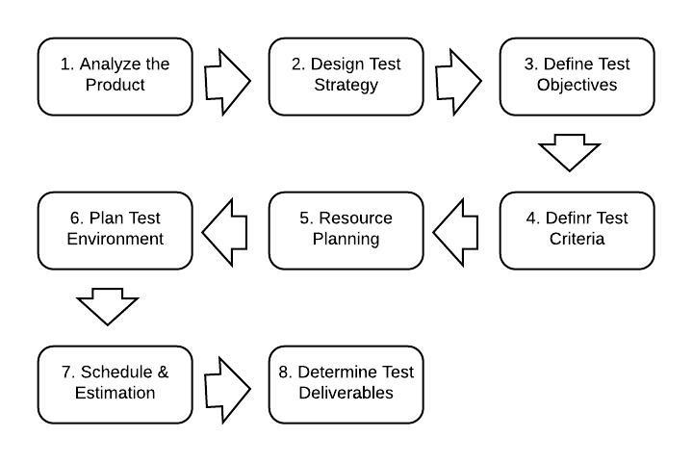

|  |  |  |  |  |  |  |  |
| --- | --- | --- | --- | --- | --- | --- | --- |
|  | | | | |  |  |  |
|  |  |  |  |  |  |  |  |
|  | | | | | | | |
|
| **Agile Test Plan 1** | | | |  |  |  |  |
|  |  |  |  |  |  |  |  |
| **Project Name:** | E-Gunj Bazaar | **Browser:** | Google Chrome, Mozilla Firefox and Internet Explorer |  |  |  |  |
| **Test Case ID:** | 1 | **Version:** | Version 1 |  |  |  |  |
| **Written By:** |  | **Description:** | Agile Test Plan of Login |  |  |  |  |
|  |  |  |  |  |  |  |  |
|  |  |  |  |  |  |  |  |
|  |  |  |  |  |  |  |  |
| •       **Agile Test Plan 2** | | | |  |  |  |  |
|  |  |  |  |  |  |  |  |
|  |  |  |  |  |  |  |  |
|  |  |  |  |  |  |  |  |
| **Project Name:** | E-gunj Bazaar | **Browser:** | Google Chrome, Mozilla Firefox and Internet Explorer |  |  |  |  |
| **Test Case ID:** | 2 | **Version:** | Version 2 |  |  |  |  |
| **Written By:** |  | **Description:** | Agile Test Plan of Version 2 |  |  |  |  |
| **Tested By:** |  | **Tested On:** | 10-jan-21 To 21-Jan-21 |  |  |  |  |
|  |  |  |  |  |  |  |  |
|  |  |  |  |  |  |  |  |
|  |  |  |  |  |  |  |  |
|  |  |  |  |  |  |  |  |
|  |  |  |  |  |  |  |  |
| **Test** | **Action** | **Prerequisites** | **Expected Results** | **Actual Results** | **Pass?** |  |  |
| 1 | Testing registration functionality | Internet Connection Required | User and Supplier Register and get mail | Registration created successfully. | T |  |  |
| 2 | Testing login functionality | Internet Connection Required | Both user can Login | Login successfully. | T |  |  |
|  |  |  |  |  |  |  |  |
|  |  |  |  |  |  |  |  |
|  |  |  |  |  |  |  |  |
| •       **Agile Test Plan 3** | | | | | |  |  |
|  |  |  |  |  |  |  |  |
|  |  |  |  |  |  |  |  |
| **Project Name:** | E-Gunj Bazaar | **Browser:** | Google Chrome, Mozilla Firefox and Internet Explorer |  |  |  |  |
| **Test Case ID:** | 3 | **Version:** | Version 3 |  |  |  |  |
| **Written By:** |  | **Description:** | Agile Test Plan of Version 3 |  |  |  |  |
| **Tested By:** |  | **Tested On:** | 30-jan-21 To 5-Feb-21 |  |  |  |  |
|  |  |  |  |  |  |  |  |
| **Test** | **Action** | **Prerequisites** | **Expected Results** | **Actual Results** | **Pass?** |  |  |
| 1 | Testing User can Save their profile | Internet Connection Required | Data save successfully in database | Action successfully done. | T |  |  |
| 2 | Testing Supplier can add Details | Internet Connection Required | Supplier can add successfully | Add Successfully. | T |  |  |
|  |  |  |  |  |  |  |  |
|  |  |  |  |  |  |  |  |
|  |  |  |  |  |  |  |  |
| •       **Agile Test Plan 4** | | | | |  |  |  |
|  |  |  |  |  |  |  |  |
|  |  |  |  |  |  |  |  |
|  |  |  |  |  |  |  |  |
| **Project Name:** | E-Gunj Bazaar | **Browser:** | Google Chrome, Mozilla Firefox and Internet Explorer |  |  |  |  |
| **Test Case ID:** | 4 | **Version:** | Version 4 |  |  |  |  |
| **Written By:** |  | **Description:** | Agile Test Plan of Version 4 |  |  |  |  |
| **Tested By:** |  | **Tested On:** | 15-Jan-24 To 25-Jan-24 |  |  |  |  |
|  |  |  |  |  |  |  |  |
|  |  |  |  |  |  |  |  |
| **Test** | **Action** | **Prerequisites** | **Expected Results** | **Actual Results** | **Pass?** |  |  |
| 1 | Testing User can Book Service | Internet Connection Required | Book Service | Book successfully | T |  |  |
| 2 | Testing Payment Will Done. | Internet Connection Required | Payment Done | Payment Sucessfully | T |  |  |
|  |  |  |  |  |  |  |  |
|  |  |  |  |  |  |  |  |

6) PROPOSED ENHANCEMENT:

* In future I can add more customizable screen features.
* I will also add EMI payment options.
* I will try to make the user Trace order.

7) CONCLUSION:

E-Gunj Bazaar System web application has been developed by me through applying my knowledge gained in college, browsing some sites and through the help of internal and using my own knowledge related to the subject itself.

No Project can be teamed as ‘Perfect’ in real sense and these always remain scope for further improvement and so that helps to develop a new version. I am always eager to know some new points and validations related to the projects and which give me more knowledge and helps me to create new version.

I would like to thank the project guide and organization staffs that extended all their support and helped me to complete this project successfully.

8) BIBLIOGRAPHY:

* WEBSITES:
* <https://www.w3schools.com/>
* <https://stackoverflow.com/>
* <https://www.phptutorialpoint.com/>
* <https://www.tutorialpoint.com/>
* <https://www.github.com/>
* https://www.youtube.com/